ALICE’S AMERICANIZED MISADVENTURES

by

DICK D. ZIGUN

Copyright © 1980-1990 by Dick D. Zigun
All Rights Reserved.
C/O CONEY ISLAND, USA, INC.
1208 Surf Avenue
Coney Island, N.Y. 11224
(718) 372-5159
“I fear it is true that there are no children in America.”

-Lewis Carroll
Diary Entry 9/3/1880

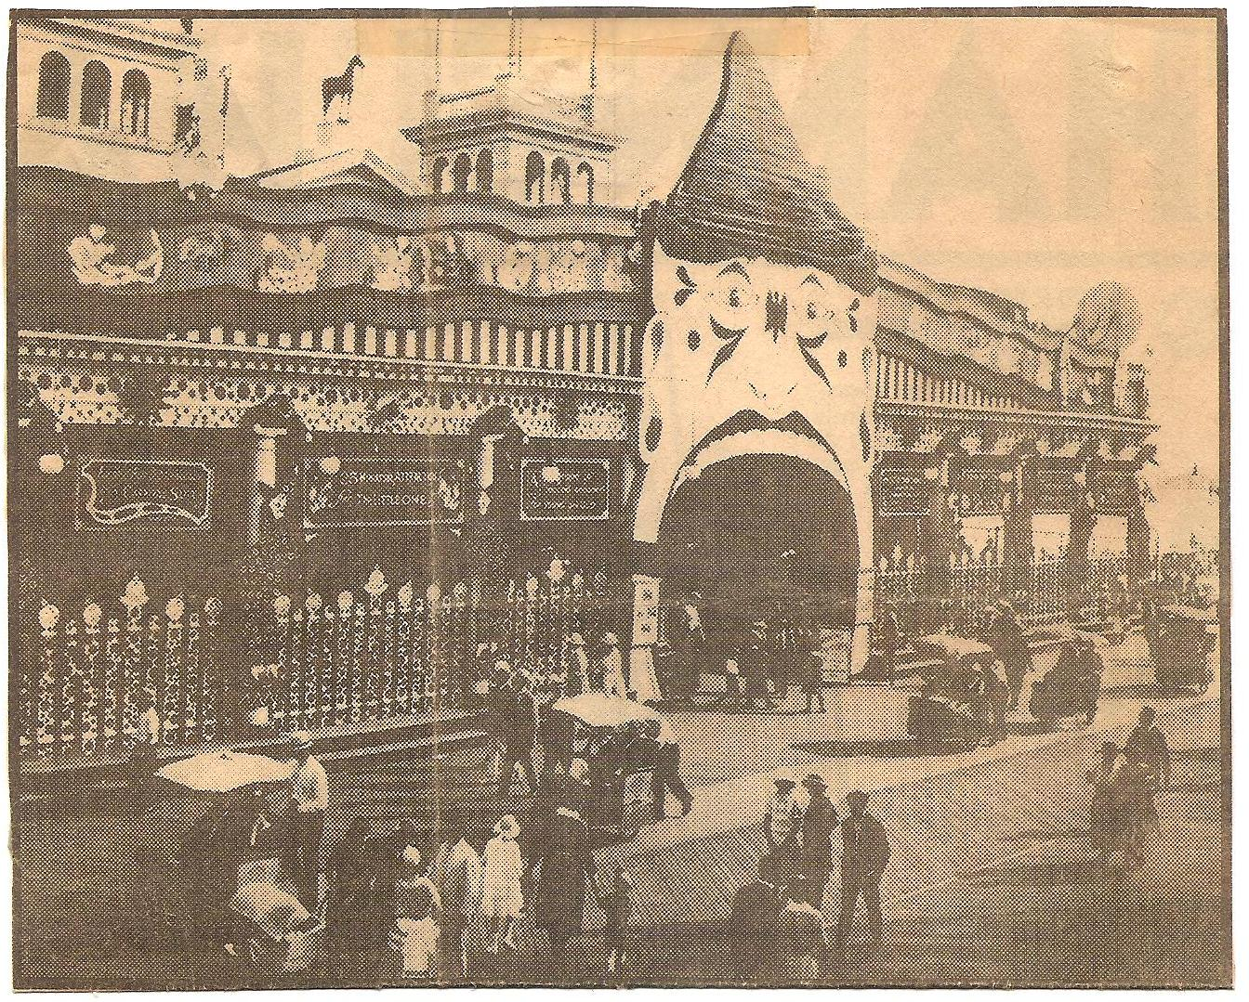
-George C. Tilyou’s STEEPLECHASE PIER
Atlantic City, NJ

This play is dedicated to Anynsley, Jecklerie, Dena, Illana, Megan, Michelle, and, of course, my sisters Rhondi and Renee, and, of course, all the little girls.

This play is a remake/deconstruction/reconstruction of the book ALICE’S ADVENTURES IN WONDERLAND by Lewis Carroll, 1865.

This play was originally commissioned by the Mark Taper Forum/Center Theatre Group, Los Angeles, 1980.

PRODUCTION HISTORY

1980 Mark Taper Forum, workshop

1982-1988 New Dramatists, readings

1988 Dorset Colony House

1990 Sideshows by the Seashore, WORKSHOP

THE PEOPLE IN CHARGE:
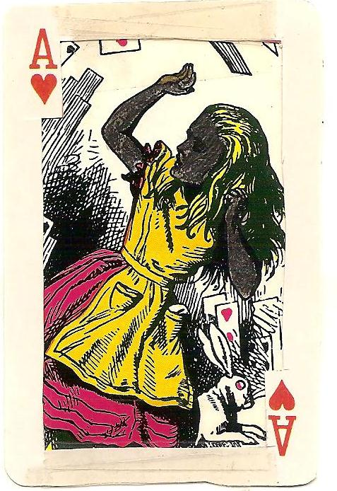
ALICE E. NEUMAN:
Black Female, singer, 12-30.
What, her worry?

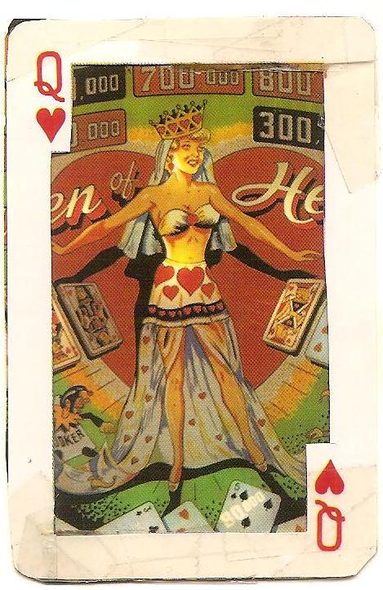
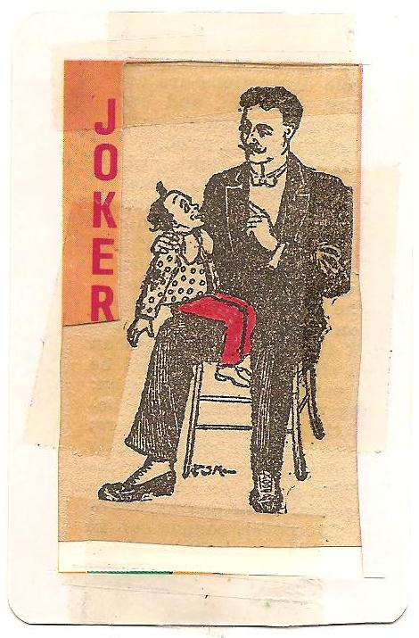

REVEREND CHARLIE: MISS AMERICANA:
Evangelical Male, singer, WASP Female, 18-30 w/
ventriloquist w/ Victorian punky red hairdo, always
handlebar mustache, 30-50. silent but fluent in
Doubles as THE MAN WHO WEARS mime, movement, or sign
MANY HATS, & SANTA CLAUS. language. Doubles as
GHOST, CLOWN, RAT, UFO HANDS, & FRENCH POODLE.
THE “IN” CROWD:

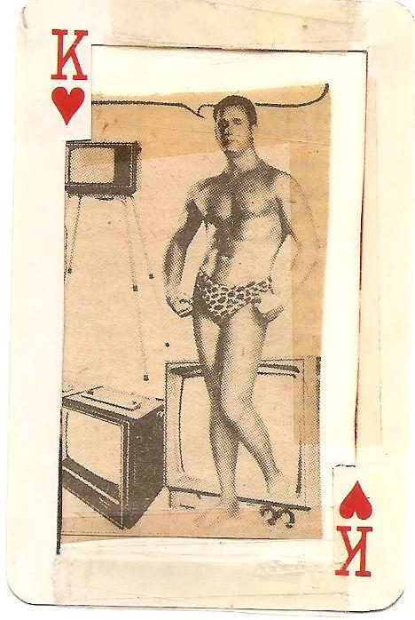
MR. AMERICANA:
Muscle Man, 25-40, 6ft plus,
w/ video cameraman experience.
Doubles as GHOST, CLOWN, RAT,
JAILBIRD, JECKLER, UFO HANDS,
& YALE BULLDOG.

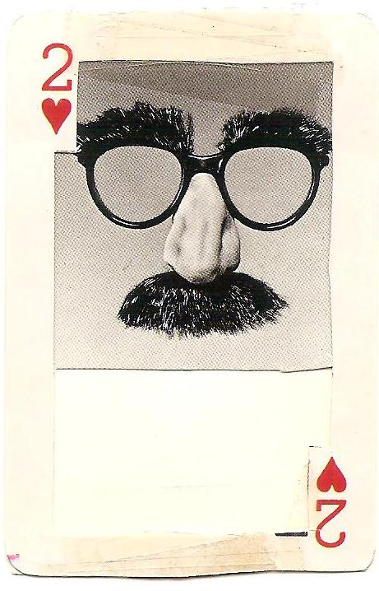
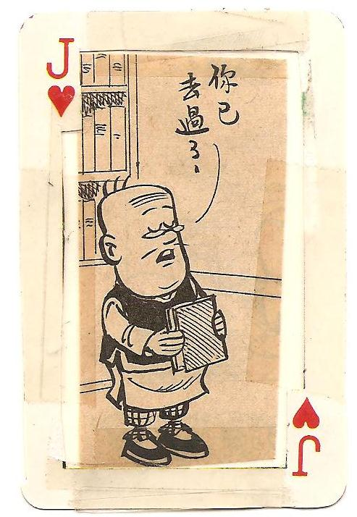

PROFESSOR PEANUT: BUGS:
Little Person (Dwarf/Midget), Jewish Male,
18-70, Asian Male, if possible. vaudevillian, 40-90,
Doubles as GHOST, CLOWN, RAT, with cartoon voices.
MAN FROM MARS, JUNIOR, & UNCLE
SAM IN A BARREL.
THE “OUT” CROWD:

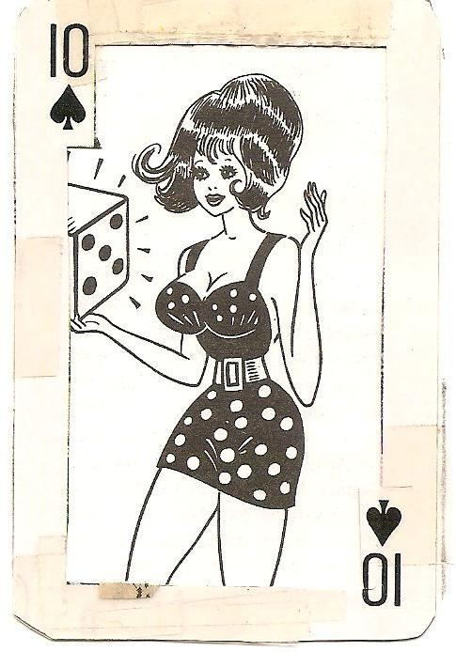
MADAME X:
Buxom Bombshell, Female or Drag,
18-30, in hot pink beehive wig.
Doubles as SKELETON, SILHOUETTE,
ALICE, RAT, JAILBIRD, HECKLER, UFO
HANDS, DICEHEAD, & HUNG JUROR.

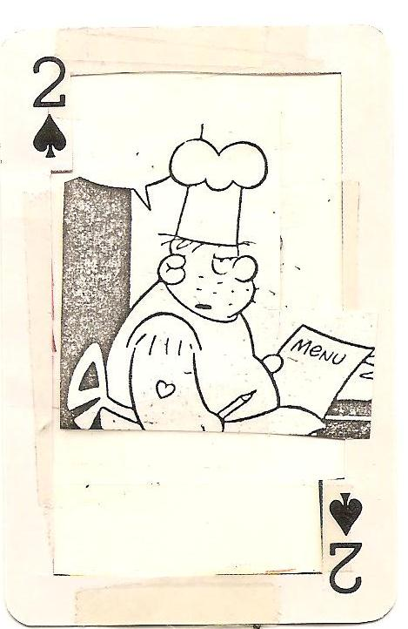
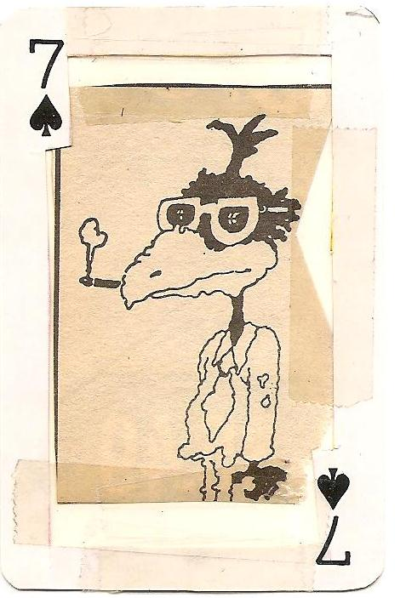

GOOSEBUMPS: COOKIE:
Hispanic Female, 18-70, Overweight Male Greaser
very street. A tapdancer, w/ tattoos, 25-50.
if possible. Doubles as RAT Doubles as GHOST CHEF,
CHEF, UFO HANDS, DOMINO HEAD, RALPHIE RAT, UFO HANDS,
VERY BALD EAGLE, HUNG JUROR, & 8-BALL BRAIN.
& PUSSYCAT.

PROLOGUE

(Two walls of stretched white paper suggest a modern living room. There is a comfortable white armchair, also modern. A portable television set in a white cabinet faces upstage, away from the audience. A large, modern white clock hangs on one of the paper walls. It is six a.m.)

(ALICE enters. She wears a white bathrobe, black and white striped knee socks and black high top sneakers. She carries a glass of milk. The glass is clear, with no markings.)

(ALICE sits in the chair, reaches behind it and reveals a container of Nestle’s Quick. She stirs and makes chocolate milk. She drinks.)

(ALICE turns on the TV with a remote control switch. The TV broadcasts The Howdy Doody Show theme song.)

(The hands on the clock move to read eight a.m. ALICE switches the channel with her TV remote control. The TV broadcasts The Mickey Mouse Club theme song.)

(The hands of the clock move to ten a.m. ALICE changes station. TV broadcasts I Love Lucy theme song.)

(The hands of the clock move to twelve noon. ALICE changes station. TV broadcasts Looney Tunes cartoon theme music.)

(The hands of the clock move to read two p.m. ALICE squirms and changes stations. TV broadcasts the unmistakable sounds of a Three Stooges routine.)

(The hands of the clock move to four p.m. ALICE reaches behind the chair and reveals a book. She flips quickly through it and then lets it slip to the floor. She changes stations. TV broadcasts theme song of American Bandstand.)

(The hands of the clock move to eight p.m. ALICE nods and naps, wakes up, changes stations, nods and naps again. TV broadcasts Twilight Zone theme music.)

(The hands of the clock spin, pick up speed and continue to spin. TV broadcast begins to sound like a video tape played in fast forward — a chipmunk-like audio of network programming.)

(As the hands of the clock pass eleven p.m., the sound of a cuckoo clock is heard eleven times in a row. The cuckoos seem to stop abruptly as the hands of the clock jerk to a halt at ll:59 and 59 seconds.)

TV AUDIO
We interrupt our regular programming to bring you the following special news bulletin:

TV/REV. CHARLIE (Sings)
The most valuable pocket-watch in the world has just been stolen. Once owned by the Reverend Charles Dodgson, better known as Lewis Carroll, author of the Alice In Wonderland books, the timepiece is worth over one million dollars!

Oh, you better watch out
Or you better not watch
You wouldn’t watch this
Who’s wearing that watch
Reward for return of my
Great-great-great-great—grand uncle’s watch!
He stole it from museum
He’s wearing weird disguise
He knows not right from wrong from left
So be sure to call the cops and hide!

(One of the living room walls made of stretched white paper tears and rips as a six foot Easter Bunny who smokes a cigar and bears a resemblance to BUGS Bunny breaks through into the room.)

(BUGS hangs a cardboard sign over the hole he has just made in the wall. The sign reads:)
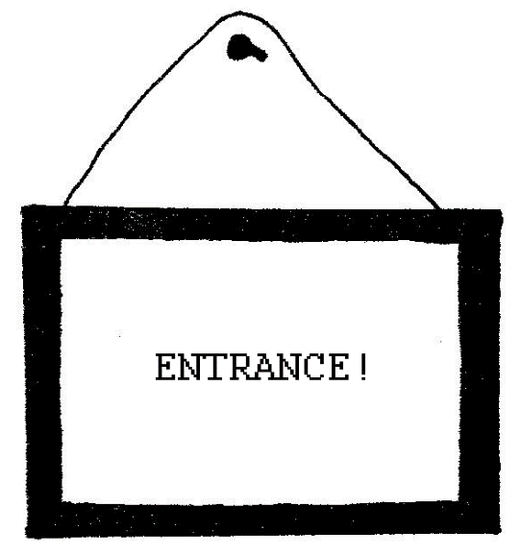

(BUGS is played by an actor whose face and body are totally disguised in rabbit costume. Besides his ever present cigar, BUGS also wears a purple derby and vest, wire rim glasses and royal purple kid gloves. When he speaks, it is with the accent of an old nightclub comic’s take-off on a Jewish BUGS Bunny. With the cigar in his mouth, he employs the classic vaudevillian sense of delivery and timing.)

BUGS (Sings)
Put your right foot forward,
Put your left foot out,
Do the Bunny—Hop:
Hop — Hop — Hop.

(He pulls an antique silver pocket-watch from his vest, opens the watch, checks time, snaps lid shut and twirls the watch on its chain. As he continues to swing the watch, BUGS moves closer and closer to ALICE and swings and sways the watch in front of her eyes. She is mesmerized.)

TV/REV. CHARLIE
MY watch! The watch! MY watch! MY watch!

BUGS
I got a million of ‘em...

(He pulls up his sleeve to reveal a furry arm covered in wristwatches.)

ALICE
...one million smackers...wow...hello, I’m -

(BUGS kisses her wet and full on the lips.)

BUGS
Hello? Good-bye!

(Sings)

I only came to say:
I must be going!

(BUGS reveals a black magic marker, goes to the un-torn white paper wall and draws the rough outline of a door. He reveals another cardboard sign and hangs it over the “door” he has just drawn. The sign reads:)
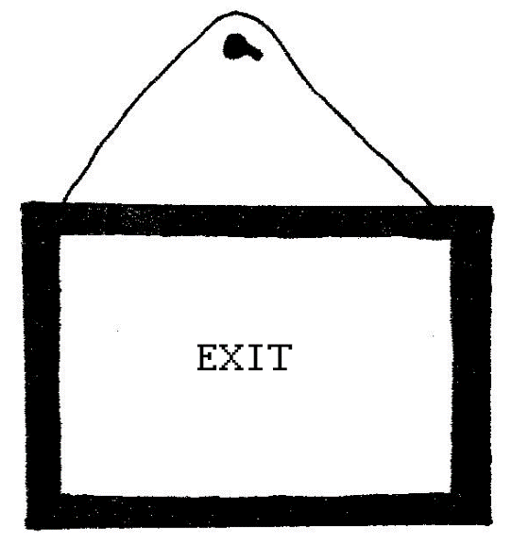

(BUGS draws an elevator button next to the door’s outline. He discards the magic marker and pushes the button. Panel slides within the frame drawn on the white paper wall.)

(Sound Cue: “Ding”.)

BUGS
Going down...

(He dives into the "elevator" opening. The panel shuts. He is gone.)

(ALICE runs to the wall and pushes the button.)

(A loud whistle comes from the TV.)

TV/REV. CHARLIE
Hey! Wait for me! Wait for me!

(Sound Cue: “Ding”.)

(The elevator door opens. ALICE hesitates, runs and picks up the TV and runs for the open door. The TV screen is seen for the first time. REVEREND CHARLIE is seen in mustache, white collar and black reverend’s hat - ALICE enters the elevator with the TV just as the doors start to close. They just make it. The door slams shut.)

(BLACKOUT.)

SCENE 1

(Strange music begins to play in the dark — music for timeless and weightless free fall.)

(Spot from above lights up the closed elevator door, now free of the rest of the wall. The white living room is gone. The stage is otherwise dark.)

(Sound Cue: “Ding”.)

(The elevator door parts to reveal the TV suspended by wire, mid—air, in front of a paper cranky perpetually moving with black ink on white paper drawings of descending floors inside a tall building. 10th floor/9th/8th/7th/6th/5th/4th/3rd/2nd/1st/ basement/sub—basement/furnace room/underground parking garage/ foundation/bedrock/etc.)

(Under the video image of REV. CHARLIE’S face on the floating TV is the caption: “Reverend Charles Dodgson V”.)

TV/REV. CHARLIE
Alice, the girl; Bugs, the bunny; and I, the TV personality... you can call me Reverend Charlie, seem to be falling down an elevator shaft to the center of the Earth!

(The elevator doors close on the TV.)

(Sound Cue: “Ding”.)

(Elevator doors open on BUGS suspended on wire, mid—air, Peter Pan style. He “floats” and reaches through the outside of the paper doorframe and hangs a sign which remains over the elevator during the rest of the scene. The sign reads:)
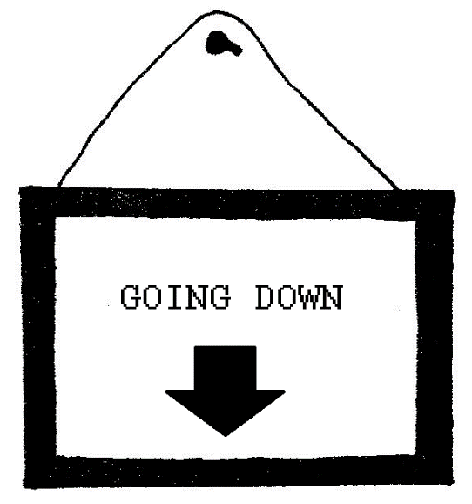

(Doors close on BUGS.)

(Sound Cue: “Ding”.)

(Doors open on TV.)

TV/REV. CHARLIE
I was keeping my eyes closed, I was ready to crash...but nothing happened. Either the elevator shaft is very deep or we’re all falling so slow that we have plenty of time to look around and wonder what the hell is gonna happen next.

(Household objects on wire fly by, up and out. Dishes and books and chairs and telephones, etc.)

(Doors close on TV.)

(Sound Cue: “Ding”.)

(Doors open on ALICE, also suspended by wire, mid-air, Peter Pan style. Hidden fans blow her costume and hair. During ALICE’s speech, the paper cranky begins to show moving drawings of subways, mine shafts, layers of rock, lava, garbage dumps, oil deposits, ruins of ancient civilizations, etc. Some companion three dimensional objects fly up and out also suspended on wires.)

ALICE

(Sings to tune of Willie Nelson/Hecklersy Cline’s WORRY:)

Worry?
Me worry when wonder will wander?
Why worry?
What worry where wow what a view?
Free fall?
For fear of a fracture from floating?
Catch you next fall
Undead, underworried, unglue.
Crazy?
Me worry no gun me no passport
Who’s worried?
Underground, underworld who?
Me worry?
Beneath un-American tunder?
I’m Alice for flying not Alice for crying
What, me worry? Boop—boop—be—do.

(Repeat last verse)

(Doors close on ALICE.)

(Sound Cue: “Ding”.)

(Doors open)on BUGS, eating carrots and chewing a map, all in mid-air.)

BUGS
...honky-tonk...hoity toity...honky-tonk...hoity toity...

(Doors close on BUGS.)

(Sound Cue: “Ding”.)

(Doors open on ALICE.)

ALICE
...honky—tonk...hoity toity...I don’t have the slightest idea what those words mean, but I know they’re important for etiquette and they are very buzz words when you need something to say...down, down, down...down, down, down...I can’t look, ohh! Ohh! Ohh!...somebody, help! I miss you very much all of a sudden, TV...I wish you were with me, falling...maybe the six o’clock news would explain exactly what’s going on...I wonder what time it is...

(Doors close on ALICE.)

(Sound Cue: “Ding”.)

(Doors open on TV.)

TV/REV. CHARLIE
Alice talks and talks. Sometimes I laugh like a hyena. There’s nothing else we can do. Alice talks again and now Alice gets sleepy. She’s having a very strange dream about the Fat Lady in the Funhouse.

(Doors close on TV.)

(Sound Cue: “Ding”.)

(Doors open on BUGS, who laughs like the Fat Lady in the Funhouse.)

BUGS
...ha—ha-ha...etc...

(There is a voiceover from TV/REV. CHARLIE during the visual of BUGS laughing like the Fat Lady in the Funhouse.)

TV/REV. CHARLIE (Voiceover)
When suddenly: Time Lapse!

(Doors close on BUGS.)

(Sound Cue: “Ding”.)

(Doors open on TV.)

(Behind TV, paper cranky shows a descent into cave drawings, cobwebs, stalagmites and candles; a spooky underground cavern.)

TV/REV. CHARLIE
When suddenly – down, down, down – dust, dust, dust, crash after crash through cobwebs covering a cave filled with bats and underground rivers and slimy rocks covered with dripping white candles. Closer and closer, closer and closer the ground comes up at us!

(Doors close on TV.)

(Sound Cue: “Ding”.)

(Doors open on BUGS.)

BUGS
Hop — hop — hop! Down - down — down! Fasten all seatbelts... Stop — stop — stop!

(Doors close on BUGS.)

(Sound Cue: “Crash! Crash! Crash!”)

(Sound Cue: Broken “Diinnng”.)

(ALICE stumbles out of the doors. The paper cranky is gone.)

ALICE
...wow...

(She hiccups.)

...thank goodness that’s over...

(She kisses the ground. She collapses.)

...TV...are you there?...silly rabbit?...where are you?

(She faints.)

(Sound Cue: “Diinnng.”)

(BUGS stumbles out of the elevator. He checks the time on the pocket-watch.)

BUGS
My—my, my—my—my—my-my...

(He throws the watch off stage.)

...how time flies...

(BUGS reveals a clarinet. He bends down and slaps ALICE to. ALICE sits up. BUGS plays THE BUNNY HOP theme on the clarinet and then sings the last line of the chorus:)

BUGS
...Hop—Hop—Hop...enjoy your stay, little girl...gotta go!

(BUGS takes the elevator sign off the door and reveals a new sign which reads:)
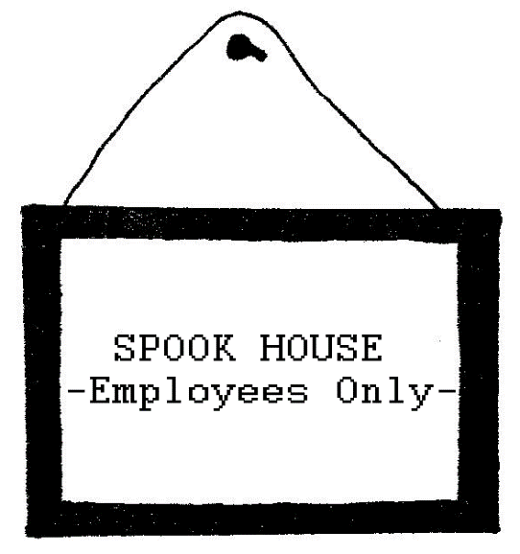

(Light Cue: The vertical shaft of light bumps to a hard focused horizontal shaft of light, a spooky white beam cutting across an otherwise dark stage. The elevator door disappears and is replaced by a Spook House facade: repeating doors drawn in black on stretched white paper. BUGS hangs the "Spook House" sign on these doors and runs off, laughing, in a flash.)

(Sound Cue: Keys in locks, bolts slide, chains rattle.)

(ALICE tries, but cannot open any of the wall of locked doors.)

(Two GHOSTS enter from either side of the stage — not the doors. The GHOSTS are each dressed in a simple white sheet over the head. They both wear black gloves. They surround and spook ALICE.)

ALICE
Lord, have mercy on my soul! Help! Help! Somebody... anybody... get me away from things that go bumping in the night. Get me outta here before I abandon all hope. Help!

(The GHOSTS step back and bow politely.)

GHOST #1
...at your service, can we be of assistance?

GHOST #2
...name your wishes...what do you desire?

ALICE
I wish I were back up on the surface.

GHOST #1
...but you’ve only just come...

GHOST #2
...won’t you stay, pretty please?

ALICE
Where am I? Who are you?

GHOST #2 (Laughing)
...information...postcards...maps...souvenirs...

GHOST #1 (Laughing)
Welcome...

ALICE
What a strange uniform the tour guides wear here —

(The GHOSTS present ALICE with a collapsible telescope.)

Thank you.

GHOSTS #1 & #2
...no problem...

(ALICE looks through the scope.)

ALICE
…wow…wow…wow…wow…oh, man! Whoo-hoo! Yes, yeah, yeow!

(The GHOSTS face her in a certain direction.)

Wow! That’s some really big neon sign! Look at that: “Wonderland, USA!”

(ALICE tries the doors again. Locked.)

ALICE
How do I get out of this place? Into that place?

GHOST #2
Sorry...no exit...

GHOST #1
So, sorry...

(As the GHOSTS exit, they hang a new sign on the wall of doors which reads:)
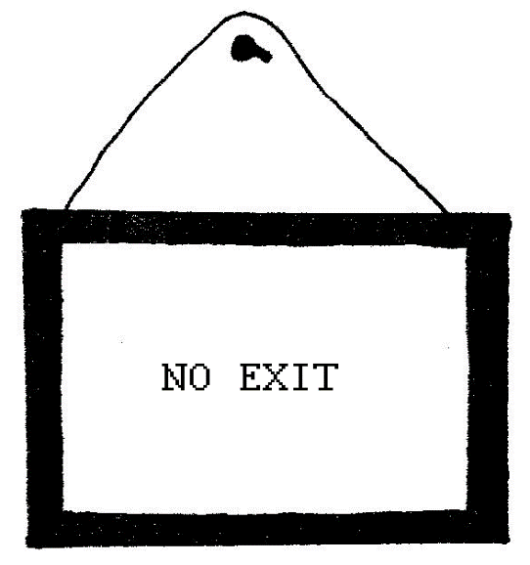

ALICE
I guess I should have made a reservation...instead of just jumping into things...

(Sound Cue: Whistle from above. Then, slide whistle.)

(A white gloved hand, on a wire, drops from above and presents ALICE with a small key on a gold chain.)

Thank you!

GOOSEBUMPS (from above)
Hey, no problem!

ALICE
What a strange vending machine...wow...the key to the city!

(ALICE takes the key from the hand. The hand disappears above. ALICE tries the key in several doors. None open.)

...the key to the city, isn’t that nice, but not the key to the Spook House...I suppose I’d need a skeleton key to get out of here!

(A SKELETON enters, stands in front of ALICE and puts out his hand which, of course, wears a black glove. ALICE gives the tiny key to the SKELETON. The SKELETON bends down and inserts the small key into an unnoticed small door, twelve inches tall, in the crazy patterned wall of locked doors.)

Thank you!

SKELETON
No problem.

(The SKELETON unlocks the door for ALICE and exits.)

(ALICE turns the key back and forth, locking and unlocking the small door.)

ALICE
So that’s where it fits...

(ALICE unlocks and finally opens the little door with a creak.)

(Sound Cue: TAKE ME OUT TO THE BALLGAME. Crowd boos and cheers.)

(Light Cue: Bright colored lights from a color wheel stream through the small open door.)

ALICE
...look at that! Look at that! Will you look at that!...whoa...

(ALICE pushes her face up to the small, open door.)

(Sound Cue: “Diinnng”, as TAKE ME OUT TO THE BALLGAME continues to play.)

(The TV falls from above out of one of the other doors in the wall of locked doors that make up the set. One of those doors opens elevator style and spews out the TV and then shuts closed with the “Diinnng”. The TV falls to the stage. The TV cabinet breaks but the video, after suffering some static, returns but with Horizontal Hold problems.)

TV/REV. CHARLIE (Aside:)
Ow...Jesus Christ...

(REV. CHARLIE calls for ALICE who is still peeking into the open door behind the TV.)

Alice?...ALICE?,..AALLIIICCEE!

ALICE (Still at door)

Mr. TV Personality! How you doing? What’s news?

TV/REV. CHARLIE
Alice! Alice! Come out, come out, wherever you are! You’re out of my depth perception! Are you hurt? Speak to me! Are you a guest hostage of unknown underground hospitality? AALLIICCEE! Speak to me!

ALICE (Still at door)
Well...it’s hard to say, exactly, Mr. TV. You see, right now I’m looking at the meanest, greenest, loudest, hottest little baseball stadium you ever saw…wow...and on top of this stadium, see, there’s this big neon sign that blinks on and off and it says WONDERLAND, U.S.A., see...oh, a triple! Oh, I missed a triple!...but I can’t even get my foot through the door! Goddamn!

TV/REV. CHARLIE
ALICE!

ALICE (Still at the door)
Bug off, TV, I’m busy!

TV/REV. CHARLIE
Alice, look at me when we talk!!

(ALICE shuts the door and locks it. End musical theme, end colored shaft of light through the door. ALICE puts the key on a gold chain she wears around her neck. She walks over to the TV, angrily, and is about to kick it when she takes her first good look at REV. CHARLIE on the video screen. She suddenly crosses herself and kneels before the TV.)

ALICE
Bless me, Reverend…Forgive me, for I have sinned…

TV/REV. CHARLIE
Charles Dodgson the Fifth, TV Reverend, Ph.D., M&M, B.S.,

ALICE (Beginning to cry)
Reverend...Reverend...

TV/REV. CHARLIE
Yes, Alice?

ALICE
Are we in hell?

TV/REV. CHARLIE
No, Alice... Hell wouldn’t be quite this much fun.

ALICE
Praise the Lord, Reverend...ah, Reverend...

TV/REV. CHARLIE
Call me Charlie.

ALICE
Reverend Charlie, am I bad?

TV/REV. CHARLIE
No, Alice. You just tried to get my watch back from the rabbit.
Maybe the rest was just indigestion, something you ate?

(Sound Cue: Whistle from above. Then slide whistle. The TV is suddenly yanked above and out by a wire.)

ALICE (Yelling up)
Reverend Charlie, don’t leave me!

(A different style of TV set, but showing the same shot of REV. CHARLIE appears, mid-air, suspended by wire.)

TV/REV. CHARLIE
Whoopee! More fun than a barrel of monkeys! I haven’t had this much fun since the flying nun! Oh, relax! Don’t worry, be happy! Give a yell if you need me, I’m going to go look around.

(The TV is hoisted up and out by wire. ALICE takes the key off the chain round her neck, bends down and unlocks the little door. Musical door theme and lights begin and continue.)

ALICE
...even if my head WOULD fit through, what would I do about the rest of my body? You know, I wish I had some reducing pills so I could grow very small...but where, down here, would I buy them?

(A GHOST enters, wearing a white chef’s hat, apron, and carrying a covered platter. It crosses to ALICE.)

GHOST CHEF
Trick or treat?

(GHOST CHEF uncovers the tray. A clear, plain drinking glass and clear glass pitcher and glass stirrer sit on the platter. The pitcher is filled half way up with a florescent green liquid. Other GHOSTS enter and crowd around ALICE. Each GHOST carries a glass of the green glow. They compete for ALICE’s choice.)

GHOST #1 (Draining its glass)
Drink me...

GHOST #2 (Draining its glass)
Drink me...

GHOST #3 (Draining its glass)
Drink me...

GHOST CHEF (Draining its glass)
Drink me!

ALICE
I’m not going to do THAT in a hurry!

(Aside:)

I better look first and see if it’s marked brand name or Brand X poison...

GHOST #1 (Hiccupping)
If you drink Brand X Poison...

GHOST #2 (Hiccupping)
It is almost CERTAIN...

GHOST #3 (Hiccupping)
To give you indigestion...drink me...

GHOST #2
Drink me...

GHOST #1
Drink me...

GHOST CHEF
Drink me!

ALICE
Well...this is sort of a fun Spook House...and I don’t see any label marked Brand X...so...eenie, meenie, miney, moe...

(She pours and takes a small sip of each.)

GHOST CHEF (Ala Campbell’s Soup)
Mmm—Mmm, good? Mmm—Mmm, good?

ALICE (Licking her lips)
…very interesting...

GHOST #1
Hamburger? Frankfurter?

GHOST #2
Pizza-burger? Veggie—burger?

GHOST #3
Coca Cola?

GHOST CHEF (With a French accent)
All mixed up in a blender...good, yes?

(Light Cue: Strobe Light.)

(ALICE hiccups and screams.)

(GHOSTS exit. The wall of closed doors and the one small door, open and emanating music and light, grow large in size until the small door becomes just big enough for ALICE to fit through if she ducks. The colored lights and TAKE ME OUT TO THE BALLGAME both grow in intensity and volume together with the wall of doors.)

(ALICE walks on her knees, hidden under her bathrobe.)

ALICE
(belch)…wow...that drink must have been liquid essence of diet pill, after all! I must only be ten inches tall, if that, and just the right size for getting through the door and to that ballgame...

(As ALICE heads for the door the strobe stops. A GHOST, now much taller than ALICE, enters and slams the door shut. The GHOST laughs and exits. ALICE tries to open the door. It is locked.)

(Sound Cue: Whistle from above and then slide whistle.)

(A white gloved hand, on a wire, drops a five foot, oversized cardboard key to the city on a heavy paper-mache link chain. The key hits the floor with a thud.)

Thank you.

GOOSEBUMPS (from above)
Hey, no problem.

(The hand disappears, leaving the key.)

ALICE
Why are you playing games with me? I’m sure I’m too small now to
POSSIBLY lift it!

(ALICE tries but cannot lift the oversized key off the floor. She slips the chain around her neck and drags the key over to the door. She sits down and cries and cries and cries.)

(The GHOST CHEF, looming larger, enters with a larger covered platter.)

GHOST CHEF
Trick or treat?

ALICE
Go away...

GHOST CHEF
Coffee? Dessert?

ALICE
Leave me alone.

GHOST CHEF
Free sample?

(He uncovers the tray. An oversized cake sits on a plate with a fork. The cake is frosted in yellow and black and decorated to look like a “Have A Nice Day” Smile Button. The other GHOSTS, each munching its own similar cake, enter.)

GHOST #1
Eat me...

GHOST #2
Eat me...

GHOST #3
Eat me...

GHOST CHEF
Eat me!

ALICE
Okay...I’ll eat it!

(She stuffs her mouth with cake. The GHOSTS applaud. ALICE talks with her mouth full of cake.)

...if it makes me grow larger, I can lift the stupid key...and if it makes me grow smaller...I can try and creep right under the door...so...excuse me...

(She swallows.)

...one way or another I’ll get into that little ballgame and I don’t care what happens!

(The GHOSTS grab ALICE by each limb. Some pull, some push.)

GHOST #1
One way?...

GHOST #2
This way?...

GHOST #3
That way?...

GHOST CHEF
My way?...

(BLACKOUT.)

SCENE 2

(Horizontal beams of white light cross the empty, dark stage.)

(A GHOST enters wheeling a table upon which is a scale model of the set for Scene One: the wall of locked doors done in a very large doll—house scale.)

(The GHOST reveals a cardboard sign and re-labels the miniature wall of doors:)
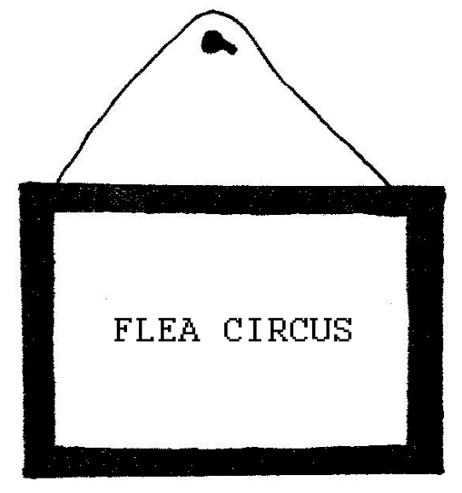

(The GHOST pulls off its white sheet. Underneath is a CLOWN in traditional CLOWN makeup: bald wig, orange hair, white face, red nose, oversized shoes, orange gloves.)

(Light Cue: Strobe light.)

(The CLOWN shrinks to its knees as ALICE enters, on tiptoes, limping and holding her head and stomach.)

ALICE (In strobe)
This way?...that way?...one way?...which way?...

(The strobe ends. The horizontal beams of light iris down so that ALICE has to bow her head to keep her face inside the low ceiling of light. ALICE chokes, unlocks a tight necklace and examines her now tiny key to the city.)

Curiouser...and curiouser...

(Two other CLOWNS, one in blackface and one half white/half black face, enter on their knees. They carry balloons on strings, filled with helium. They hand one balloon to the CLOWN already on stage. The three small CLOWNS, before speaking, each breathe in some helium gas from a balloon. They scratch for fleas throughout.)

WHITE CLOWN
Curiouser...

BLACK & B/W CLOWNS
Curiosest…

WHITE CLOWN
Curiousamous…

BLACK & B/W CLOWN
Curiousamousamous!

(The CLOWNS circle around ALICE’s knees and dance a cakewalk around her.)

ALICE (on helium)
Wow...they all forgot how to speak good gobbledygook... wow... what gobbledygooker I’M talking…I’m walking…I’m enormous…
gi-hugic…hugantic!

(The CLOWNS circle ALICE, barking, meowing, making other animal noises. They rub up against her legs. ALICE, acting tall, steps out of the circle of CLOWNS. She wobbles. She walks as if on a tightrope. Her head sticks above the horizontal beam of white light and is lost in the dark.)

ALICE (on more helium)
Yeowza—Yeowza, Ladies and Gentlemen! I feel like a Freak Show’s TALL, skinny lady! I must be nine feet tall if I’m an inch, and that in my stockings! I’m a giant so tall - how tall? — so tall, I can’t see my feet! You can’t see my head!

(CLOWNS applaud ALICE. ALICE, still headless, holds her hands up for silence.)

WHITE CLOWN
Try and open the doorous!

BLACK CLOWN
Doorer!

B/W CLOWN
Doorest!

WHITE CLOWN
Yes, open the dooramor!

(They wheel her to the miniature set on the table. ALICE takes
out her miniature key.)

Look, it’s the keyaramous!

BLACK CLOWN
Keyer...

B/W CLOWN
Keyest...

WHITE CLOWN
Yes, that’s the keyamous to the little dooramous, alrightamous!

ALICE

(Says: “Do you know where the doorous leads to?” in Pig Latin)

Ooday ooyay oh-nay erebay e-thay oorousday eadlay otay?

(CLOWNS somersault.)

WHITE CLOWN
All Star Game... Tickets...

BLACK CLOWN
Ticketser…

B/W CLOWN
Ticketsest...

BLACK CLOWN
Gobbledygook...

B/W CLOWN
Gobbledygooker –

ALICE

(In Pig Latin: “Did you say tickets for the All Star game?”)

Id-day ooyay aysay ickets-ay orfay e-thay all-lay arstay ame-gay?

(ALICE rushes over to the miniature set, bends down and unlocks the tiny door with her key. She opens the door.)

(Sound Cue: TAKE ME OUT TO THE BALLGAME musical theme.)

(Light Cue: Color wheel door effect.)

(ALICE tries to fit her head through the door. It won’t go. She closes the door. The music and light disappear. She opens the door — they come back. Close. Open. Clooooose. Opencloseopen
closeopencloseeee...Opeeeeeeeeeeeeeeen. Close!! She tires of playing on/off with the door—song-light and slams the door shut. She gets her finger in the door.)

ALICE
Ow! More hopelesserebor than ever!

(ALICE sits down and cries.)

WHITE CLOWN
Poor little Giant Girl!

BLACK CLOWN
Giantessamous!

B/W CLOWN
Giantessemessamess!

(They each take out a hanky and sit around ALICE. They cry. They blow noses, each other’s noses, etc. One CLOWN brings in a bucket of water. He dips his hanky into water, rings it out, dips, rings, etc. The rest do the same.)

(ALICE begins to use two different Freudian personae and “talks” to herself, alternating two different stances: BABY on her knees, and MOMMY on her toes:)

ALICE BABY

(On her knees:)

Shut-up! Shut-up! Shut—up! Sometimes when I cry, I find it necessary to give myself a good talking to. It’s lots of fun pretending to be two different people.

ALICE MOMMY
You ought to be ashamed of yourself!

ALICE BABY
I am not!

ALICE MOMMY
A big girl like you!

ALICE BABY
Big? Look who’s talking!

ALICE MOMMY
Who?

ALICE BABY
Who in the world am I?

ALICE MOMMY
Who in the world am I?

ALL THREE CLOWNS
THAT’S the big question!

(They reveal rubber bulb bicycle horns and scatter, as if traffic, honking. A chase ends with the bucket of water being tossed — only to shower confetti. One by one, the CLOWNS “drive off” and exit, honking. The last, B/W CLOWN, turns and changes the oversized cardboard sign on the miniature set to read:)
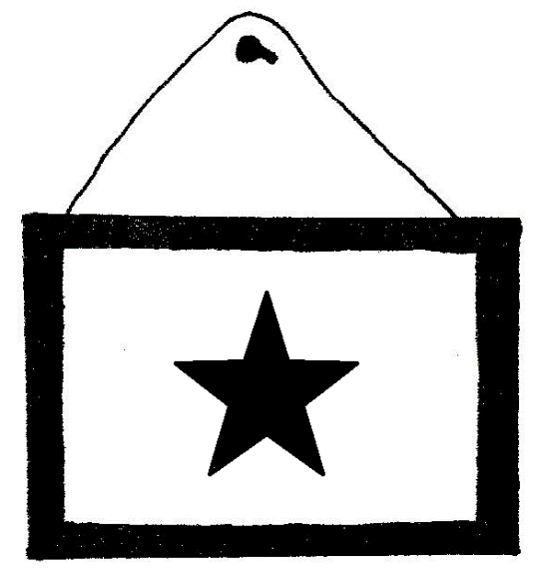

B/W CLOWN
Think over all the other boys and girls you know, your friends, your rivals, you might have been reincarnated into any of them...

(He too exits. ALICE tiptoes up to the small door to the ballgame. She puts her ear to the door.)

(Sound Cue: Knocks on a door.)

(ALICE unlocks and opens the door. She peeks into the door as an upstage beam of vertical, multi—colored light silhouettes another girl, same size as ALICE, singing a song:)

SILHOUETTE DOROTHY
“Somewhere over the rainbow way up high”

(Sound Cue: Knocks on a door.)

“You’ve got to ease on down, ease on down the road...”

(ALICE slams the door shut. The upstage illusion disappears.)

ALICE
I’m sure I’m not Dorothy...there’s no place like home, there’s no place like home...nuts! I’m not like that country girl at all...not at the start of an adventure, I don’t think...

(Another knock sound cue.)

(ALICE opens the door. Another silhouette girl sings a song:)

SILHOUETTE PETER PAN
“I won’t grow up!” “I don’t want to go to school!"...etc.

(ALICE slams the door again. The illusion is gone.)

ALICE
...and I’m pretty sure I can’t be Peter Pan either...because Peter’s always played by some old gal in disguise...I noticed, I notice all sorts of things like that and he...she?....ohhh... half-man/half-woman...a he/she knows so little about street smarts, really! Besides, he/she’s he/she and I’m me/me...and ohhh...like, crazy, man, crazy...

(Sound Cue: More knocks.)

(ALICE grabs the doorknob of the little door and holds it shut. Knocks continue all through her following speech as a muffled, off—stage voice tries to sing the song TOMMORROW from ANNIE.)

ALICE (Sings)
I blink and fall and bump my head inside the TV tube
Someone hugs me I’m a hero someone yells that I’m a boob
I think you might be right no wrong no way that I can tell
If I’m a primetime network star or locked up in a padded cell
Or if I know my name or have a roof above my head
Is aching bad at least that tells me I’m not dead.
My brainwaves go awash I wink I’m Dorothy leaving Oz
Home sweet home too tilted twisted witch in cellar smelling blah
The rent too high and Oz went out when Wizzy flew away
Love or leave it Wonderland is where we moved today
If more fall out of stories and crawl in under my skin
Just commit us all to Wonderland rooms are vacant down that inn.

(More knocks from door. ALICE cries.)

(Sound Cue: Rainstorm and thunder.)

I wish TV Reverend Charlie or Mother Goose, the secret service or SOMEBODY would try and come check me out...I’m very, VERY tired of being M.I.A., all alone and down here...held hostage in the center of the Earth.

(CLOWNS enter, on knees, with balloons, cross to ALICE and pat her knees.)

WHITE CLOWN (W/ helium)
What seems to be wrongest?

BLACK CLOWN
Wrongererer?

B/W CLOWN
Wrongamous, dear LITTLE Alice?

WHITE CLOWN
Giantesseses!

BLACK CLOWN
Giantessamess!

ALICE
I can’t find that stupid, dumb Bunny!...boo-hoo—hoo...boo—hoo—hoo... boo—hoo—hoo...

(BUGS enters, on his knees, travelling the stage like Al Jolson, with a straw hat.)

BUGS
Ahhh, what’s up, Alice?

(He twirls the pocket-watch on the chain. WHITE CLOWN reveals a cap pistol and shoots the watch.)

Stop killing time! Stop killing time!

(BUGS slaps the WHITE CLOWN and takes the gun.)

Come on! I’m late for the ballgame! Come on, come on!

(The CLOWNS form a dance line behind BUGS. The three CLOWNS and BUGS hop up, down and offstage.)

Hop—Hop—Hop...Hop—Hop—Hop...

CLOWNS
Hop-Hopper—Hoppest...Hop—Hopper—Hoppest...

(They are gone.)

ALICE
Curiouser...and curiouserer..and curiouserer..and curiousererer…

(ALICE cries even harder; then she girds herself up and faces downstage.)

...I MUST find that wabbit!...

(Behind ALICE’s back, inside the miniature set on the table, a door, but not the small door, opens. The furry arm of BUGS reaches through the open door, removes the large cardboard sign with the star and hangs a new sign which reads:)
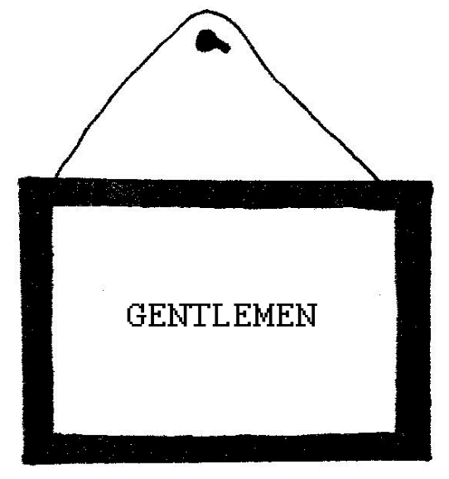

(ALICE turns, reads the new sign, and knocks on the door which BUGS’S arm has returned to and shut. No answer, but giggles respond to her knock.)

(ALICE turns her back on the miniature set. The door opens. BUGS’S arm reaches through the door and turns the cardboard sign around so that it now reads:)
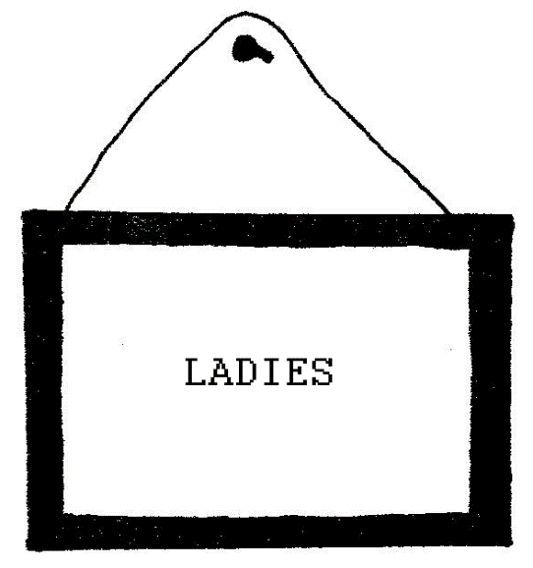

(BUGS pulls back his arm and slams the door shut. ALICE turns and looks at the new sign. She crosses to the miniature set, eagerly, but before she arrives, BUGS rapidly sticks his arm through the door, turns the sign again, to read “GENTLEMEN”, pulls his arm back, shutting the door. ALICE, angrily, turns the sign herself, so that once again it reads: “LADIES”. She opens the door. There is nothing behind. Blackness. She peeks in.)

ALICE
Hello?...yoo-hoo?...ohh, Wabbit?...oh, Mr. White Wabbit?...

(No answer. She shuts the door.)

(Sound Cue: Whistle from above. Then slide whistle.)

(A white gloved hand, on a wire, falls from above and hands ALICE a candy Easter Bunny wrapped in colorful foil.)

Thank you.

GOOSEBUMPS, (From above, w/ helium)
Hey, no problemer!

(The hand exits, above. ALICE unwraps the large candy bunny — it is made of white chocolate. ALICE bites off its ears. She chews. She smiles. She likes it. She swallows.)

(Light Cue: Strobe Light.)

(Suddenly, ALICE is on her knees and once again dragging the five foot cardboard Key to The City by a heavy, paper-mache link chain around her neck.)

ALICE
Oh, wow; oh, wow; oh, wow — I must be shrinking again! I’m shrinking! Stop it! Stop it! Too small! Stop it!

(ALICE screams. She panics and attempts different ways to stop her shrinking. All fail. The strobe light continues. She stares at the chocolate bunny — throws it off. The strobe slows down but still does not end. ALICE speaks and moves in slow motion in the flickering light as somehow, the miniature set exits the stage.)

What – a – close – call - ! That – candy – must – have – been – dietetic – chocolate… - …wow… - I’ve – never – been – this – small – before… - NEVER – not – even – when – I – was – born!

(The slow strobe continues. ALICE cries harder.)

(Sound Cue: Water dripping and Waves.)

(Strobe stops as the horizontal beams of white light grow taller in height — way over ALICE’s head. She speaks normal again, though in sobs.)

ALICE
Boo—hoo—hoo...boo—hoo-hoo...all I seem to do is cry here...
boo—hoo—hoo...I’m so small no one can help me…I’m so small...
boo—hoo—hoo...I better watch out for the tears that I wept when
I was nine feet tall...boo—hoo—hoo...or maybe even taller than the up-higher state building...

(ALICE cries.)

GOOSEBUMPS (from above)
Hey, Yoo—hoo!

(Two gigantic cardboard cutout waves, on wheels, enter the stage. The waves rock back and forth, in front of ALICE, in opposition to each other, stage left to stage right, stage right to stage left. ALICE is washed back and forth, back and forth. The large key weighs her down. She tries to tread water. As she speaks, water sometimes pours into her mouth.)

ALICE SINGS

(Source Music: 96 Tears)

Uh-oh, I’m shrunken, Help-Help, I’m sunken
Too many teardrops, drown in my tears
2-3-4-5-96 tears
5-6-7-8-96 gallons
3-2-1 inches tall, 1-2-3 times I’m down
S-O-S, (gulp), drown in my tears

(Source Music: Wipeout)

Wipeout? Surfboard! That’s the key!

(Hidden by the waves, members of the ensemble hoist ALICE and the five foot cardboard key in the air, as if floating on the cardboard waves. ALICE is perhaps given a cardboard S.O.S. flag and hoists it over her makeshift life-raft/surfboard. She paddles.)

Surf, Surf, Surf the keys
Symbols lock the stream
Merrily, verily, perily, warily,
Weird and wet the dream

(Source Music: Something pirate. A cardboard boat, flying a large Jolly Roger, sails onto the cardboard horizon.)

Pirates! What, me, worry about Pirates?

(Source Music: Jaws. She paddles off in another direction. An ominous cardboard fish fin appears.)

Sharks? What, me, worry about sharks?

(Source Music: Chaos. She paddles off. The waves themselves begin to violently toss about.)

Tidal wave!?! Oh, my, me, am gonna worry about a...(gulp)(gulp) (gulp)...

(ALICE falls off the key into the waves. She struggles to swim. The chain, once again, drags her by the neck.)

ALICE
Little girl overboard! Life preserver! Life saver! Lifeguard!
Coast Guard!...Robinson Caruso! Won’t SOMEBODY save me!!!

(She cries.)

(A cardboard speedboat, with appropriate sound effect, crosses the stage over the waves. As the boat exits, a taut wire in front of the waves pulls a water skier on stage. The skier is RALPHIE RAT, a fat rat with buck teeth, whiskers, tail, etc. RALPHIE RAT wears a dirty, ripped, wet Mickey Mouse t—shirt and a bathing suit. He wears sunglasses and a nose plug. He wears gray gloves. He puts his hand against his brow, scout-style, and carefully looks over ALICE. ALICE, meanwhile, has a little talk with herself.)

ALICE BABY
What, is that a speedboat? Watch out, Alice. I smell a rat!

ALICE MOMMY
...a water rat, alright...but then we can’t be choosy about who to ask for help anymore...

ALICE BABY
I’d rather die.

ALICE MOMMY
Help! Help! Hey, Sailor! Over here!

(The RAT makes no response.)

ALICE BABY
Maybe he doesn’t speak English, stupid! He’s a rat, stupid! Sprecken ze dutch? Espanol?

(The RAT does not respond.)

ALICE MOMMY
Maybe you better take lessons in Rat—Talk, Alice! Listen to this! RAT TRAPS, CATS AND POISON!

(RALPHIE RAT angrily spits a stream of water at ALICE.)

Well?...I got his attention!

ALICE BABY
...but I guess he doesn’t like threats...watch out!

(RALPHIE RAT swims over to ALICE and grabs her in a headlock.)

Thank you, sir...(choke)...I hope I’m not causing a problem?

RALPHIE RAT
No problem? Listen up, kid! No thank you!

(He tightens his hold on ALICE.)

And if I’m going to save you, which I might, or might NOT do... then: Number One! The name’s Ralphie. Ralphie Rat!

(He dunks ALICE, She gasps for breath.)

Number Two: I’m the leader of the gang!

(He dunks ALICE again.)

Number Three: Who’s the leader of the gang?

ALICE
Ralphie Rat!...(choke)…Ralphie Rat...(gulp)...but can’t we talk someplace else?!?

(RALPHIE RAT snaps his fingers. A motorboat engine revs up. RALPHIE tightens his headlock on ALICE. They waterski off stage, the large key in tow.)

(BLACKOUT.)

SCENE THREE

(In the dark, jungle drums. Bongo drums. Chanting.)

(A circle of light, stage right only. The rest of the stage remains dark.)

(CANNIBAL RATS dance in a circle around an oversized Campbell’s
Soup can. A bonfire burns around the base of the paper-mache can. Free standing paper-mache walls suggest the inside of a cave.)

(The CANNIBAL RATS wear bone in the nose, bone necklace round the neck. They carry spears topped with doll heads. The RATS dance to the drums as they shake their grass skirts. They dance with knives and forks clenched in hand, with black and white checkered cloth napkins tucked under their chins. The CANNIBAL RATS drool as they dance. One RAT, in apron, seasons and stirs and slices vegetables into the can of boiling vegetarian soup.)

(Two more CANNIBAL RATS enter carrying an oversized micro TV set tied to an oversized TV antennae balanced on their shoulders. They toss the “captive” into the boiling soup can.)

TV/REV. CHARLIE (On screen wearing pith helmet)
They indeed were a queer looking party that asked me for lunch-

RAT CHEF
Hey! Who you calling "queer"?

(He hits the TV with the bone he has been using to stir.)

TV/REV. CHARLIE
—all drooling from the mouth, savage and tasteless...

(Light Cue: Crossfade from the CANNIBAL RATS, TV and soup can to a circle of light, stage left, only. The drums continue to beat, but aside from stage left, the rest of the stage is now dark.)

(Stage Left, RALPHIE RAT enters, dragging ALICE by the five foot key and oversized chain she wears round the neck. In front of RALPHIE RAT and ALICE, a free standing paper-mache unit suggests the entrance to a cave. The mouth of the cave is blocked by an
oversized, cardboard, Coca—Cola bottle-cap. The words “Club House” have been hand-painted under the Coke logo on this large bottle-cap. RALPHIE points this cave “door” out to ALICE.)

RALPHIE RAT
Sure, Alice, sure, the baseball stadium, the neon sign...just around the bend...but why not take a break at the Club House, meet the gang, dry off, have a beer?...

(They reach the bottle-cap door of the cave. RALPHIE RAT rotates the oversized cardboard Coke bottle-cap, like it was the revolving door to a building. He pushes ALICE through the revolving door into the cave. He follows. As they exit through the revolving bottle-cap, the audience is shown the inside/other side of the revolving bottle-cap. An oversized cardboard sign hangs on the cork lining of the bottle-cap and reads:)

FORGOT TO INCLUDE! whoops

(The lights crossfade once more, from the outside to the inside of the cave and pick up the CANNIBAL RATS just as ALICE and RALPHIE RAT enter. The CANNIBAL RATS line up in front of the TV in soup-can so that ALICE’s view is blocked. The drums suddenly come to a stop. One or two CANNIBAL RATS bow, on their knees, before RALPHIE.)

CANNIBAL RATS
Ralphie’s back! Ralphie! Speech, Ralphie, speech! Who’s the meat?

RALPHIE RAT (Throwing kisses, ala Cagney)
Hiya, gang! Hiya! Rat—friends...Rat-finks…“You dirty rats, you”! Shutup! Shutup! Cut the small-talk! Let me say this ALL in one mouthful:

(He sucks in a deep breath.)

Alice, this is the gang. Gang, this is Alice. Alice, we insist that you stay for a bite...Gang, Chow Time! COME AND GET IT!!!

(A RAT takes charge of ALICE and binds her hands, behind her back, to the oversized key, as if to a post. The drums begin to play once again. The RATS dance.)

ALICE
TV, TV, what does it mean? Eyewitness news me!

TV/REV. CHARLIE
Your blind date, the psychopath who calls himself Ralphie Rat, seems to be a patron saint of some underground religion they practice...

RALPHIE RAT
Shutup, Rabbi!

(RALPHIE turns off the TV sound. REV. CHARLIE continues to talk, unheard, on the screen and into the scene makes use of a crystal ball and magnifying glass. RALPHIE RAT pushes away the RAT CHEF, stirs and bastes the TV. He samples the soup. He spits back into the can.)

ALICE
Bad taste?

RALPHIE RAT (Yelling into ALICE’s face)
Unkosher!

ALICE (Aside)
P.U. ...bad breath!

(RALPHIE plugs ALICE’s mouth with an apple. The RATS place ALICE, Joan of Arc style, into the Campbell’s soup-can.)

RALPHIE RAT
Bad taste! Bad taste! People think rats are always in bad taste! Don’t they gang? Yesss! Why, you ask? Whyyy? For good reason! Gooddd! Have you ever tasted a rat? Yuck!...(belch)...given the chance, I’d like to taste something better. Something: ...yum—yum! Good taste!

CANNIBAL RATS
Yum—yum! Good taste! Yum-yum!

RALPHIE RAT (Licking ALICE’s neck)
THIS is the most tasteful thing that I know —

(Licks his own arm)

- and THIS is the least!

(RALPHIE snaps his fingers. The drums switch to a dance beat. The CANNIBAL RATS ritualistically bring RALPHIE his ceremonial outfit on a satin pillow: bone earrings and a pair of Mickey Mouse ears with an elastic chin strap and a bite out of one ear. The bone and the ears are made out of paper-mache. RALPHIE is given a skewered and roasted Mickey Mouse doll on a spear. He chews it. The CANNIBAL RATS circle the soup-can again. RALPHIE RAT dances in the opposite direction. RALPHIE, about to eat, breaks into song instead.)

Hey, waiter! Waiter!
What’s this in my soup?
There’s no flies in the goop!
The girl is spice but
She’d be so nice stuffed with fliessssszzzzzz!

RAT CHEF (Aside to ALICE, sings)
Hey, Alice! Alice!
That’s some pickle you’re in!
He means to munch on your skin!
The boss gets dibs then
The pack will rib you to bones!

CANNIBAL RAT CHORUS (“Dem Bones” tune:)
Taste buds, taste buds,
Good taste buds.
Taste buds, taste buds,
Good taste buds.
Taste buds, taste buds,
Good taste buds.
What’s tasty on the menu tonight?

(Oh, I wish she were an Oscar Meyer wiener!)

RALPHIE RAT
Shutup!
Hey, Ratsos! Fatsos!
Is this a dish or a dance?
How come the ants in the pants?
The girl is meat and
She’d be so sweet a la...cucaracha—cucaracha-

CANNIBAL RATS (Interrupting his dance)
Hey, Ralphie! Ratsie!
We’ve Mickey Mousied enough;
Less drool or we’ll call your bluff:
Serve the girl or we just
Might start serving Ralph!

RALPHIE RAT (Punching RATS)
WHO’S the leader of this gang
WHO’S feeding yous and me?

CANNIBAL RATS (Under duress)
R—A—L, P—H-Y
T-A-S-TY Rat!

RALPHIE RAT
Ralphie Rat!

CANNIBAL RATS
Rat Fink!

RALPHIE RAT
Ralphie Rat!

CANNIBAL RATS
King Rat!

RALPHIE RAT
Let’s use her on a
Sausage pizza pie!

RAT CHEF
Meat pie!
Run along and sing a song
To praise our fatty king!

CANNIBAL RATS
R-A-L (Elementary thinkin’)
P—H—I—E (Why? Because we’re with him, that’s why!)
T-A—S—TY Rat!

(A musical interlude. The RATS dance off and return with clothes and undergarments from other girls sacrificed in the past. They knot garment to garment, like a kite’s tail, and attach the long tail of garments to RALPHIE RAT’s costume.)

...Judy...Cindy...Mary...Mindy...Dianne...Susan...Linda...Lucy...
(RALPHIE RAT runs the length of his new tail through his fingers. He savors certain garments for their personal memories. He reaches the end of his long, long tail and tickles ALICE under the chin with it.)

RALPHIE RAT (Aside)
Mine is a very looooonnnng and baaaadd tale, you know —

CANNIBAL RATS
Alice! Alice! Alice! Alice!

(They seize her and begin to undress her. Part of her wet bathrobe is torn and tied onto the tail of garments. ALICE’s binds are untied. Her gag is loosened.)

ALICE
RAID!!! All right, up against the wall, you smelly rodents! I’m taking you all in for offending my sense of smell!

(Music/Dance/Everything ——— freezes.)

(ALICE alone moves on stage. She climbs out of the soup-can and yanks on RALPHIE’S garment tail. He falls over and in doing so starts a chain reaction that tumbles all the other RATS.)

I BEG your pardon!

(She yanks the tail off RALPHIE’S costume.)

A knot! Your tail has a knot in it! Please do let me fix it!

(She rips the tail apart.)

Oops...I’m SO sorry! I didn’t mean to rip the thing up to shreds!!!

(A RAT moves toward ALICE.)

ALICE
RAID!!!

(It freezes. ALICE rips more tail.)

You’re so easily offended you know!

(She moves towards the RATS. They crawl back a step.)

RALPHIE RAT (Standing)
There ain’t no cops here! After her! After her!

(The RATS stand and begin to chase ALICE.)

(Blackout.)

(Lights up on tableau vivant of ALICE untying the TV as RATS advance.)

ALICE
TV, TV, help me! I think I want to cancel this show!

(Blackout.)

(Lights up on tableau vivant of ALICE, running with the portable TV, pursued by the RATS.)

TV/REV. CHARLIE
Alice suddenly found herself in the midst of a rat race.

RATS
Get the girl! There she is! Where? Over there! Get that girl!

(Blackout. Lights up on tableau vivant of ALICE pursued. Blackout. Tableau vivant. Blackout. Tableau vivant. The frozen glimpses of the rat race lead in and out and around the revolving bottle cap at the cave entrance. Blackout. Tableau vivant. Blackout. Tableau vivant of an out—of—wind ALICE and very tired out RATS.)

After the rat race had gone on for half an hour or so...

(Blackout. Tableau vivant of ALICE and RATS collapsed on the ground. They are all unfrozen and moving.)

RALPHIE RAT (Aside to ALICE)
Truce...truce…the rat race is over...cease fire...nobody won...

ALICE
You mean it?

(RALPHIE offers his hand. ALICE shakes it. The RATS boo. TV/REV. CHARLIE applauds.)

RALPHIE RAT (Aloud to RATS)
EVERYBODY wins and everybody wins prizes!

ALICE (Aside to RALPHIE)
Prizes? You said nobody won! Who’s giving out prizes?

RALPHIE RAT (Aloud to RATS)
Alice will give out the prizes!

(Aside to ALICE.)

Why, YOU, of course.

CANNIBAL RATS (Circling ALICE)
Prizes! Prizes! Ransom! Pay—off! Prizes!

(ALICE positions all the CANNIBAL RATS in a circle and then takes each RAT’s tail and puts it in the mouth of the RAT standing behind it. RALPHIE sneaks an extra bite here and there. ALICE wanders around, dripping, as the CANNIBAL RATS belch.)

ALICE
...anybody see a towel?...

TV/REV. CHARLIE
Hey, Rat fink! Ralphy Rat! She should win a Lifetime achievement
award, you know!

RALPHIE RAT
...(belch)...oh, alright...alright...

RALPHIE RAT (Aside as he turns off TV)
Shutup, Rabbi!

(He unknots and collects the clothes that made up his tail)

...alright, alright...(belch)...let me rummage around here...see what kind of garbage we got...come over here, rude little girl, dry off, these are drip dry, put these on...drip…

(He begins to throw clothing items at ALICE.)

ALICE
You won’t be naughty and look at me if I change, will you?

RALPHIE & RATS
Noooooo...

(ALICE turns the TV back on.)

TV/REV. CHARLIE (W/magnifying glass)
Who? Me? Noooooo… Go ahead, Alice

(ALICE puts on a blue dress, black and white striped knee socks and red sneakers. She ties a red bow in her hair. She puts on a white apron. She is suddenly wearing a red, white and blue, ill—fitting version of the Tenniel outfit so identified with Lewis Carroll’s ALICE and all her adaptations.)

(The CANNIBAL RATS laugh, stand and exit through the oversized bottle-cap. On the way each, they each take a good lick at ALICE’s neck.)

RALPHIE RAT (Putting ALICE in a headlock again)
Ah-ha-ha-ha! Speech! Speech!...(belch)...Speech!

ALICE
It doesn’t quite fit...it looks like a maid’s uniform…

(She cries. RALPHIE licks, laughs and leaves. ALICE is alone with TV.)

TV/REV. CHARLIE
I’m sorry they didn’t like you much, Alice…but then, would you want them to like you? They had such an unknown, underground sense of hospitality!

(Off—stage Bronx cheer.)

RALPHIE RAT (Off—stage)
Shutup, Rabbi!

(ALICE pounds her fist into the palm of her hand.)

TV/REV. CHARLIE
That’s a very…provocative dress you’ve got on Alice…

(She laughs.)

ALICE
What are you doing? Stop it! Creeps! Did I say something wrong? Lose my temper? How DID all that start? Maybe THEY need a new mouthwash!

TV/REV. CHARLIE
Find the true path, that’s the first thing you should do if you want my blessings, Alice, second of all-

(She clicks off the TV mid—sentence.)

ALICE
I know one thing for sure, I’m getting out of this cannibal scene! Forget the baseball game...maybe. Maybe forget the key...maybe later. Right now, for sure, I just want to find a way out!

(She picks up the blank TV and exits herself through the revolving oversized bottle-cap.)

(BLACKOUT.)

SCENE FOUR

(Dark stage. A follow spot picks up REV. CHARLIE, on TV, talking on a screen of a set held in ALICE’s hand. Only her hand, arm and TV are seen.)

TV/REV. CHARLIE (As Dan Rather)
Everything seems to have changed since we left the rats and the cave. Watch out, Alice! Things are spinning out of my control! There are things happening that make nonsense look like nonsense. Whatever happened to the Spook House, the flea circus, the big key and little door to:

(He whistles TAKE ME OUT TO THE BALLGAME as his image fades into thin air on the TV screen. The iris of the follow spot widens to include ALICE.)

ALICE
...all vanished. Completely.

(She wanders off. Follow spot out.)

(Dark stage. A second follow spot picks up BUGS, who hops onto stage in a white cowboy hat, white cowboy vest with badge, white kerchief, mirrored sunglasses and shotgun. BUGS takes the pocket-watch out of his vest and licks it.)

BUGS
Whoa, whoa, whoa horsey! Yup, supper time...the boys’ll fix me some grub.

(He crosses the stage in his follow spot. ALICE enters, in a spot, sneaking, tip—toe, following BUGS, unseen. The TV is now off, with no image. She puts her index finger to her lips.)

(BUGS and ALICE both exit.)

(A downspot, on the otherwise dark stage, picks up HECKLER and JECKLER - two crows. HECKLER is a little over five feet tall, JECKLER is very short for a crow, three feet or so. Both HECKLER and JECKLER are dressed in striped prison uniforms. Both wear striped hats and striped gloves. HECKLER and JECKLER both wear a paper-mache ball and chain and slam paper-mache sledge hammers down onto a large pile of paper-mache rocks.)

(Behind HECKLER and JECKLER stands a box on wheels - five feet high, three feet wide, three feet deep. The walls of the box are made of cardboard, except for the front of the box which is a door of black metal bars, like a prison. A cardboard sign over the cage door reads:)
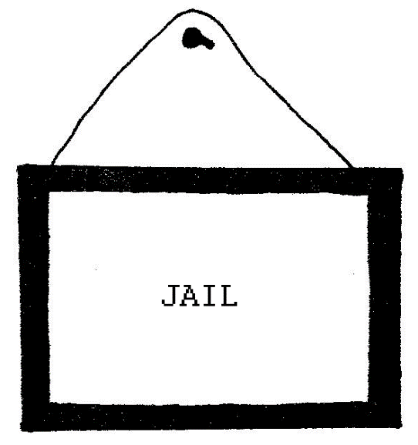

(BUGS enters)

HECKLER & JECKLER (Sing)
Watch out bossman, ain’t you heard
Yes, Boss (ooo) Yes, Boss (ahh)
Get no respect from no jailbird
No, Boss (ooo) Yes, Boss (ahh)

BUGS
Howdy, Heckler...How now and howdy, Jeckler!

HECKLER & JECKLER (Sing)
You bad, you good, you cry, you sing
You, Boss (ooo) Yes, Boss (ahh)
Your chain and ball, my wedding ring
Love, Boss (ooo) Hate, Boss (ahh)

(ALICE enters on tip-toe, stepping backwards, not aware that she’s entered the stage.)

BUGS
Why, Princess Pocahontas...

(ALICE turns with a start. BUGS aims his rifle at her.)

...where are you sneaking off to past curfew?

(He puts a feather in her hair.)

It’s ten PM. Do you know where your parents are? Looks to me like you’ve been stealing...juvenile delinquent runaway stealing clothes and TVs I see...what do you think, boys?

HECKLER & JECKLER (Sing)
Princess Poca better scram
How, Boss (ooo) Gun, Boss (ahh)
Grass is greener on the Lam
Yes, Boss (ooo) Red, Boss (ahh)

BUGS (Opening cell door)
Inside Pocahontas, and make me some carrots. Me so hungry! I’m gonna go watch some TV...boys, give me a yell when she’s done with the grub.

HECKLER & JECKLER (Sing)
We eat corn and we pass squash
Yes, boss (ooo) Yes, boss (ahh)
we don’t trust no bullalash
Yes, boss (ahh) Yes, boss (ooo)

(ALICE enters the box. BUGS takes her TV. He slams the cell door and locks it. He exits.)

ALICE
Does EVERYONE think I’m Pocahontas all of a sudden?

HECKLER & JECKLER (Sing)
Bossman call you what he please
Who, boss (ooo) Me, boss (ahh)
Pocahontas shell them peas
Eat, boss (ooo) Drink, boss (ahh)

(ALICE begins to shake and rattle the bars.)

(Sound Cue: Whistle from above. Then slide whistle.)

(A white gloved hand, on a wire, falls from above and hands ALICE a clear glass martini pitcher filled with a florescent violet liquid. Another white gloved hand drops with a glass.)

ALICE
Maybe I will...maybe I won’t...maybe I will...maybe I won’t... you know...maybe I will...whenever I eat or drink anything in this place I know SOMETHING curious is sure to happen...

(She drinks the liquid.)

Yiiicckkk!

GOOSEBUMPS (From above)
Hey, no problem!

(The white gloved hands exit, above.)

ALICE
I don’t like that stuff at all! Maybe it works...maybe it doesn’t...maybe it works...maybe it doesn’t...I hope I grow large again, I’m so SICK of being the same size as rats and rabbits and crows...no offense guys, maybe it doesn’t...

(Light Cue: Strobe light. The magician—like box on wheels that ALICE is caged in is turned l80°. ALICE is now seen through another door to the same box - a door that was its back wall until a moment ago. This door is painted in a much smaller scale. ALICE now appears a giant caged in a miniature jail building. The facade of the jail contains an identical bar door and Jail sign — like the one ALICE was just behind — but now in miniature on the facade. The rest of ALICE’s cage is now painted with brick wall, second and third story bar windows. ALICE can be seen through the bar windows and door. Her oversized arm sticks out of the roof of the jail building.)

(During the strobe, HECKLER & JECKLER are replaced with HECKLER & JECKLER marionettes. They are smaller in size, but continue the same sledge hammer action.)

(Strobe Light ends.)

ALICE (Trapped in miniature building)
I have to admit that life is much pleasanter at home where I’m not always growing larger and smaller and not always being ordered about…and yet...and yet...it’s rather curious, you know, this sort of life! Yee-ha! Here we go again! I do wonder what’s happened to me! When I used to read fairy tales, I thought, that kind of thing never happens, no way...and now, here I am! Right in the middle of one! Yee-ha! Wow! There ought to be a book written about me, that there ought! A book or a play! When I grow up I’ll write a book about all this and sell it to the movies...maybe I will...maybe I won’t...maybe I will!

(She cries)

ALICE MOMMY (With a sultry voice)
I think you’ve grown up already. At least there’s no room to grow up HERE anymore.

ALICE BABY (with high voice)
Then I’ll write my book now.

ALICE MOMMY
What will you call it, my dear?

ALICE BABY
“The Autobiographies of Alice”

ALICE MOMMY
“And Alice”
“And Alice And Alice”

HECKLER & JECKLER (Sing)
Alice here and Alice there
A. boss (ooo) L. boss (ahh)

BUGS (Offstage, tossing out bags of groceries)
Keep hammering, Heckler. Jeckler, help me with these bags of groceries I bought for Pocahontas to cook!

HECKLER & JECKLER (Sing)
Big boss, small boss, shrinking crows
Wee, boss (ahh) Tee-hee, boss (ooo)
Alice grows and grows and grows
Look, boss (ooo) Wild, boss (ahh)

ALICE
Oh?...so now Jeckler has to go and fetch the food for me to cook...dumping on me, dumping on him...I wouldn’t do it...I won’t do it! You’ll have to forgive me, little Jeckler, but I wouldn’t want to be in your shoes right now, not with this giantess feloness around...no, sir, nobody’s carrying housework to Alice!

(She works her leg through the bars and kicks the JECKLER MARIONETTE right into the air and off of the stage.)

HECKLER (Sings)
Come back, Jeckler, please don’t die
Boo, boss (ooo) Hoo, boss (ahh)
Here comes Heckler, boss, bye-bye
Too late, boss (ahh) Escape, boss (ooo)
We’re out of here!

(HECKLER MARIONETTE wanders off stage.)

BUGS MARIONETTE
Giant! Killer giant! Dangerous giant! Attack of the 50 foot woman! Call the army! Help! Attack! Help!

(He throws the miniature groceries at ALICE, then flees off stage.)

ALICE
Well, I’ll be a monkey’s uncle! The groceries he threw at me are suddenly turning into junk food.

(She picks up an item.)

If I eat one of these Slim Jim’s, it’s sure to make some change in my size .... eat me...eat me...it can’t possibly make me larger...

(She shuts her eyes, holds her nose, bites and chews.)

...it must make me smaller, I suppose...

(Light Cue: Strobe light.)

(ALICE grows smaller. The marionettes are gone and so is the box/building on wheels. ALICE is alone on a dark stage, in a followspot.)

ALICE
Too small, drat! Too small! Too small! That’s what happens when you don’t have a plan. The first thing I’ve got to do, if I’m EVER going to get my bearings in this place, is to grow my right size again and then look around. Make a plan. The second thing is to find my way to:

(She whistles TAKE ME OUT TO THE BALLGAME.)

I think that’s the best plan, first things first...let me see...let me see...how do I do it? I suppose I’ll have to eat or drink something; that seems to be the means of transportation down here...but the big question remains: eat or drink exactly what?

(She eats and she begins to bite everything in sight.)

REV. CHARLIE (Offstage)
Alice? My head is spinning, Alice! There’s so much more than meets the eye here-there’s so much underground that I’m going to have to go undercover! Alice, next time you see me, you might not see me…I’ll be dressed in disguise…

(REV. CHARLIE’s clerical collar falls to the stage from above.)

Alice, the big question certainly is...

ALICE (Stops eating)
What? What?

(BLACKOUT.)

SCENE FIVE

(Sign: A Trip To Mars)
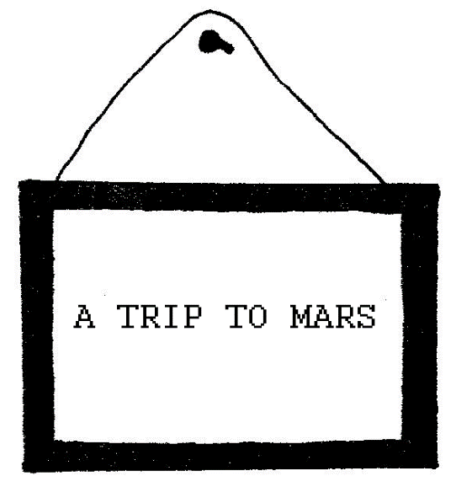

(On an otherwise dark stage, the space helmeted head of the MARTIAN appears on a ledge. His body, with two torsos running at and away from ALICE, dangles below. The MARTIAN’s space helmet is strangely alien and not at all like that of an Earth astronaut. Many plastic tubes wrap around the helmet, flowing with colored liquids. Throughout the scene, soap bubbles continually float out of the top of the helmet. The helmet is made of tinted or mirror glass. The face of the MARTIAN is not seen. ALICE enters. She stops in her tracks. She stares. TV/ REV. CHARLIE is seen on a suspended screen, now wearing a Sherlock Holmes detective hat, pipe and spy glass.)

TV/REV. CHARLIE
The Man From Mars and Alice From Earth looked at each other for some time in mutual stunned silence...Martian: Alice...Alice:
Martian...

(The MARTIAN turns the TV off. The set flies out. TV/REV. CHARLIE is gone.)

MARTIAN
Take take me to to your leader leader leader leader.

ALICE
Do you mean the President, the Pope, the Pop Star, the Parent, or I definitely love Lucy. I wanna be dizzy like Lucy when I grow up.

MARTIAN
Take take me to to Lucy Lucy Lucy Lucy.

ALICE
Lucy’s dead, sorry. You missed her. Do you want to rent a video?
Are you gonna fly to her graveyard?

MARTIAN
Are are you pulling pulling my legs legs legs legs?

ALICE
No offense, but I wouldn’t pull your legs if you paid me. Can you say: Take take me to to your tailor tailor tailor tailor?

MARTIAN
Does does tailor own own this planet planet planet planet?

ALICE
You’re very literal. No sense of humor. You’re not very earthy.

MARTIAN
Mars Mars needs women women women women.
Mars Mars needs shoes shoes shoes shoes.
Mars Mars needs blood blood blood blood.

ALICE
What the world needs now is love, sweet love…a chicken in every pot…40 across, and a mutt…a new deal…every man a king…

MARTIAN
Deal deal approved approved approved approved. When when can
you you take delivery delivery delivery delivery?

ALICE
Look, it was a joke, okay? I can’t take that kind of responsibility.

MARTIAN
Take take me to to responsibility responsibility responsibility
responsibility.

ALICE
I can’t, ‘cause I’m irresponsible. Like I told you, I wanna be
dizzy like Lucy. I lack proper heroes. Take me to YOUR leader!

MARTIAN
Repeat: Repeat: Mother Mother Goose Goose Rhymes. Rhymes. Rhymes, Rhymes.

ALICE (Clasps her hands and sings)
Simple Simon stopped a wise man,
Walking down the street;
Simple said: “Hey, baldy head!
Those shoes don’t fit your feet!”

(ALICE slaps her own face)

Egghead said: “I’m nearly dead,
And you are not much younger!
Three million mistakes I’ve made so far,
And you’ve not made a blunder!”

(ALICE clasps her hands again)

“Hey, baldy head,” the dense one said,
“You looking for your mother?
She’s in the bushes down the block,
And kissing with your brother!”

(ALICE again slaps her own face)

“I’m nearly dead”, old smarty said,
“And you’ll be willed my goat.
I might just leave you my whole house-
If I can take the boat”.

(ALICE clasps her hands again)

Oopsay simay: “Obald heada.
Iggily! Siggily! Bah!
Codeay swearo baffleo you!
Ha! Stickabee! Wickome! Ha!”

(ALICE slaps her own face again)

“To be, or not to be”, pop says,
“It’s right in front of your nose”,
“Four score and seven years ago”,
“A rose is a rose is a rose”.

(ALICE clasps her hands again)

“Hey,-baldy head!” the simplier said,
“Hey, wax that dull bald head!
The hair fell out! The brain goes next!
I’ll shine it when you’re dead!”

(ALICE slaps her own face again)

“I’m not dead yet”, the wise man spoke,
“So here’s some good advice”.
“Let’s have it”, Simple Simon said.
The wise man kicked him twice.

(ALICE curtsies)

MARTIAN
That that was unauthorized unauthorized unauthorized unauthorized.

ALICE
Like I told you, I change, oil change, Lyrics change.

MARTIAN
Loose Loose change change change change. Very very loose change
change change change.

ALICE
I live, I learn, I change my mind. Maybe Mars needs robots.

MARTIAN
What what program do do you want want want want?

ALICE
Oh, just your basic bionic.

MARTIAN
Do do you have have bionic coverage coverage coverage coverage?

ALICE
What kind of policy is that?

MARTIAN
Take take me to to your broker broker broker broker.

ALICE
I don’t seem to have any coverage for or against changes.

MARTIAN
You’ll you’ll get used used to it it in time time time time.

ALICE (Mumbles)
Big. Little. Big. Little. Big. Little.

MARTIAN
As as for the the big little little thing thing thing thing. Mars Mars has something something for you you you you.

(He writes a prescription)

One one will make make you grow grow TALLER TALLER TALLER TALLER.

(He writes a second prescription)

The the other will will make you you grow smaller smaller smaller smaller.

ALICE (With both notes)
One of what? The other of WHAT?

MARTIAN
Fill fill the prescriptions prescriptions prescriptions prescriptions.

(The MARTIAN’S two torsos hand ALICE two oversized syringes.
The MARTIAN disappears in a flying saucer.)

ALICE
Which which is which which which which?

(She jabs an oversized needle into each arm)

(Music Cue: WHITE RABBIT by Jefferson Airplane begins to play and continues, bridging the entire change into Scene Six.)

(There is NO blackout between scenes. ALICE spins and spins through a multi-media light show and colorful pulsating light. By the time the song and lights fade out for the start of Scene Six, ALICE has collapsed and rests on the stage.)

SCENE SIX

(As the song WHITE RABBIT fades out, strobe lights flash into the eyes of the audience.)

(Strobe out. A paper-mache street lamp illuminates a large cardboard wall/door similar to the amusement park mouth/entrance seen on the title page of this play. The mouth/entrance is sealed off by cardboard swinging crash doors. The cardboard eyes of the face/entrance mechanically shift back and forth. A normal size but paper-mache turns kggstands in front of the closed entrance. A cardboard sign hanging on this wall/door reads:)
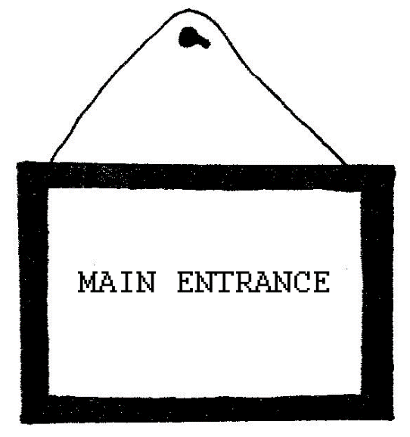

(A human sized FRENCH POODLE enters dressed in Paris fashions. She carries a golf bag that has baseball bats sticking out of it.)

(ALICE awakes in front of the turnstile, rubs her eyes and stares as the POODLE approaches and knocks on the door.)

(The door is opened a crack by a YALE BULLDOG in a blue sweater with the letter “Y”, etc. He sticks his head out. The POODLE removes and formally presents a baseball bat. A card on a ribbon is tied to the bat.)

YALE BULLDOG (Reading the card)
“For Madame X. An Invitation From Miss Americana To Her Exclusive Baseball Party”. Grrrr...

(The FRENCH POODLE bows. The YALE BULLDOG bows. They bump heads.)

Grrrr...

(The FRENCH POQDLE exits.)

(THE YALE BULLDOG goes back inside, closing the door to the mouth of the giant face whose eyes shift back and forth.)

(ALICE stands up, walks over and knocks on the door. The YALE BULLDOG sticks his head out.)

BULLDOG
Grrrr...

(Pause.)

Who’s knocking? We’re sold out! All sold out!

(He slams the door shut, going inside. ALICE bangs on the door.)

ALICE (Banging)
I want to get in! I want to get in!

(The BULLDOG opens the door a crack and sticks his head out.)

BULLDOG
Grrrr...Sold out! We been sold out for hours! Only Madame X is giving out passes and she’s busy inside counting the money! No VIP ID? Grrrr…Go away!

(He slams the door shut. ALICE bangs on the door.)

ALICE
I want to get in! I want to get in! I want to go to the ballgame!

(The door opens a crack. The BULLDOG is forcefully thrown out.)

BULLDOG (On the ground)
Grrrr...you can’t do this to me! I went to the right schools.
I work here! Grrrr...

(He goes back inside, slamming the door in ALICE’s face. The door opens a crack. The BULLDOG is forcefully thrown out.}

(A hairy, fat arm with a tattoo sticks out of the door and breaks a plate over the head of the BULLDOG. The hand disappears and slams the door shut.)

They can’t do this to me...grrrr...they can’t do this to me...

ALICE
Well, you can sit there until tomorrow but I want to get in! Grrrr! I intend to get in! I’m anyone’s equal!

(The BULLDOG checks out ALICE’s dress which is now dirty and torn.)

Don’t touch me! Don’t touch me! I can’t stand the way you creatures all instantly judge me! Grrrr! It’s enough to drive me crazy!

BULLDOG
Grrrr...

ALICE
Look, I just want to buy a ticket! What am I supposed to do? What does it cost?

BULLDOG
Anything you like! Grrrr...

(He exits on all fours.)

ALICE
Same to you, buster!

(ALICE pushes on the doors. They swing back and knock ALICE over. The doors swing back upstage and remain open.)

(The eyes of the face stop moving back and forth mechanically and focus on ALICE. They move with her and follow her movements. Two white gloved hands, on wires, drop either side of the face and give it an eerie, three dimensional feel of being alive.) .

(Inside the mouth of the face are MADAME X, COOKIE and JUNIOR. COOKIE and MADAME X are the first human faces ALICE has seen in the play aside from REV. CHARLIE on TV. MADAME X counts paper money inside of a cardboard and chicken wire ticket booth. Her hair is teased, dyed cotton candy/hot pink and is fashioned in a jagged, angular cut. She wears a pair of rhinestone sunglasses and a tight, slit up the side, plunging neckline, white dress polka—dotted with a pattern of spades - like on a deck of cards.
She also wears rubber dice earrings. COOKIE is fat, unshaved and
tattooed. A cigarette stub lives on his lips. He wears white t—shirt, white apron, white pants and white hat—the same cook uniform he first wore back in the army. JUNIOR wears baby clothes, baby hat, and sleeps inside of a paper-mache baby rocker. A black and white checkered blanket covers his face; a small lock of pink hair sticks out from his head. COOKIE and JUNIOR are both on leashes held by MADAME X.)

(COOKIE stands by a paper-mache chopping block and meat cleaver and stands at attention; sort of. Whenever MADAME X is not looking, he takes a pepper mill out of his apron, grinds a mound of pepper onto the block and snorts it. He sneezes. He snorts. He sneezes. JUNIOR sneezes in his sleep — a second behind each sneeze of COOKIE. MADAME X sneezes, scatters money and looks up. ALICE wanders inside and watches COOKIE’s routine through to a snort.)

ALICE
Hey, Mister. Mister!

(He pays her no attention. Aside:)

That sure is a strange way to eat pepper...

(The doors of the face swing back and forth by themselves as a strange laugh is heard and the hands on the wires move a bit. ALICE shivers up and down her spine. She runs over to MADAME X.)

What was that?????

MADAME X (w/ loud & unexpected Southern accent)
You talkin’ ‘bout Goosebumps? Goosebumps, that’s my pet. Yep. I own ‘im. Goosebumps: The Talking Painting On the Outside of The
Building Up There! Good pet, too! Can’t go nowhere. Eats nothin’. Don’t need a leash, not my Goosebumps!

(GOOSEBUMPS laughs again. JUNIOR sneezes. MADAME X jerks his leash so that his head jerks.)

Shut up, Hog!

(GOOSEBUMPS laughs again. JUNIOR keeps sneezing.)

ALICE
I didn’t know that buildings could talk...I didn’t know there was a single building like that in the country!

MADAME X
Only one in the world. It’s true and I got ‘im. I got me quite a collection. You wanna be my pet? I got a really nice leash.

ALICE
I...don’t...think...so...

MADAME X
You don’t catch on very fast, do you? I declare, that’s a fact! You watching me now? I want you to see this!

(She jerks COOKIE’s leash.)

Cookie! Dishes!

(COOKIE reaches off stage and brings back a container full of dirty dishes. He smashes them: Crash! After Crash! After Crash! After Crash!)

COOKIE
Do ze dishes! Do ze dishes! Do ze dishes! Do ze dishes!

(GOOSEBUMPS laughs again. MADAME X jerks COOKIE’s leash. He puts the broken dishes away. She jerks his leash again.)

MADAME X
Cookie! Junior!

(COOKIE starts to cross to the baby. ALICE grabs JUNIOR by one arm. COOKIE grabs the other.)

ALICE
No! Don’t! Stop him! I can’t watch! Please stop what he’s doing!

(MADAME X crosses to JUNIOR, who is the object of a tug of war between ALICE and COOKIE. MADAME X punches JUNIOR, who is facing upstage, in the nose.)

MADAME X
You better mind your own business! You’re a stranger here, girl!

(She climbs back into her ticket box and begins to put on pink nail polish.)

Cookie! Chop off Junior’s head.

(COOKIE beats the chopping block with his meat cleaver.)

COOKIE
Kill ze baby! Kill ze baby! Kill ze baby! Kill ze baby!

(ALICE screams.)

MADAME X
That’s a little immature. Don’t you think she’s a little immature, Cookie?

COOKIE:
Bow-Wow!

(MADAME X sings, COOKIE howls & JUNIOR sneezes & plays saxophone.)

MADAME X
You musta been a puppy once, baby!
I love the way you look on a leash
(COOKIE: Bow—wow!)
When you were only startin’
To be my pet my darlin’
I taught you sit and heel and beg and speak
(COOKIE: Bow — Wow!)
You musta been an alley mutt, Alice
I hate the way you runaway my pet
(ALICE: You gotta be kidding!)
Don’t get the wrong impression
Lying bulldog’s false confession
Here’s a treat, once a year you’ll see a vet
You gotta wag your tail and be my brand new bow—wow
So puppy, put the leash on now
(ALICE: You gotta be kidding!)

You coulda been a pedigree, Junior
But now you’re just a runt with a sneeze
(JUNIOR: Ahchoo! Ahchoo!)
Sure as pepper leads to poker
I should free you from my choker
Pass the hat for pass the pepper disease
(JUNIOR: Ahchoo! Ahchoo!)
Oh, you coulda been a pedigree, Junior
But now you’re just a—stray with a wheeze
(JUNIOR: Ahchoo! Ahchoo!)

(MADAME X unleashes JUNIOR and flings him at ALICE. She shuts her ticket box. She pushes the rocker towards ALICE.)

Oh, you mustn’t think it’s easy to score sold out tickets!
Bad, Alice! Come on, Cookie! Stay, Junior! Wipe your nose, Junior! I’m completely sold out!

(MADAME X exits upstage.)

(COOKIE breaks a dish over his head and exits as well. The doors of the mouth swing shut. ALICE is again separated from the face/wall by the turnstile. She has been left alone with JUNIOR. They hold hands. ALICE tucks him back in his crib, which is with her, downstage. She looks out into the night. Behind her, GOOSEBUMPS’ eyes and gloved hands on the wires begin to move, subtly, stealthily, whenever ALICE’s back is turned. ALICE embraces herself as if cold or scared. She quietly begins to whistle TAKE ME OUT TO THE BALLGAME.)

ALICE (Sings)
...for it’s one, two, three strikes you’re out...Jesus Christ!

(She kicks the cradle.)

So, I’m not invited, am I?

(JUNIOR, hidden inside the cradle, sneezes; and sneezes. ALICE immediately begins to rock to cradle, absent mindedly.)

Gesundheit! I thought I was on to something. Gesundheit! I found the front gate - I was doing so well. Gesundheit! A couple of minutes ago I was getting back in touch with the humans. Gesundheit! The humans were talking my language; they were even talking about baseball games! Gesundheit!

(JUNIOR begins to mix snorts in with his sneezes.)

Zip! Failure! Just you and me, kid.

(JUNIOR snorts.)

And now I’ve got this asthmatic orphan on my hands who only knows how to do two things: sneeze and play saxophone. Gesundheit! Gesundheit! I’m a mother! An unwed mother: feed the kid, wash the diapers, stay home. Stay home! Not me! Not yet! I’m not licked! Give me the choice and I’ll still choose the adventure! I’ll take the kid with me if I have to! I’ll teach him survival and one day he’ll grow up and carry my luggage! I can’t leave him here. Cookie and Madame X seem so ready to kill him. I think he had a day or two left. It’s up to me. I’d be the murderer if I left him behind.

(A big snort.)

Don’t grunt, Junior. That’s not a proper way of expressing yourself.

(Another big snort.)

If you’re going to turn into a Hog, Junior, we’re through! I mean it! Now quit being cute and go back to your sneezing!

(A long and loud and labored snort.)

(ALICE bends down to the cradle and looks under the blanket. Instead of JUNIOR, a real pig, dressed in baby bonnet, jumps out from under the blanket, out of the cradle and off of the stage. ALICE rocks the empty cradle and drapes the black and white checkered blanket over her shoulders.)

(The street lamp turns off. The stage darkens. The lights turn to ultra violet against the wall extending upstage. The gloves and the face with the moving eyes, GOOSEBUMPS, begins to glow behind ALICE, who still faces downstage.)

ALICE
Bye—bye...bye-bye, once again...sure was an ugly kid. Not a bad looking hog, but sure was an ugly kid...I used to know a few kids who might have been better off hogs...I could have helped them, if I knew how to change them...here, suee—suee—suee...we could play...if someone showed me how to do it...if someone showed me my way around here...here, suee—suee—suee...

(Sound Cue: Faint calliope music.)

(GOOSEBUMPS laughs. ALICE spins around. GOOSEBUMPS rolls her eyes, raises and lowers her hands and laughs again — which makes the two doors painted like her mouth wiggle. Through the rest of the scene, the doors move in sync with her speech and ALICE stands behind the turnstile with her hands tightly clasped behind her back.)

Goosebumps! Don’t scare me! — I’m lost! Do you know your way around here?

GOOSEBUMPS

(Miked Latino voice courtesy of actress offstage. With door and hand action)

You talkin’ to me now, Alicia?...alright! Do I know my way around here?...it depends...where you goin’?

ALICE
I guess I’ll keep going. Just going. Doesn’t matter to where.

GOOSEBUMPS (Always giggling)
Then it doesn’t matter, Alicia, which way you go...

(GOOSEBUMPS spins her eyes and laughs.)

ALICE
I mean, I’ll have to stop SOMEPLACE: City Hall, Lost and Found, Hamburger Joint...

GOOSEBUMPS
You’ll get there, Alicia, you’ll get there...if you walk long enough you’re sure to do that...

(GOOSEBUMPS laughs and then suddenly goes still. No laugh. The eyes stop shifting. The hands hang limp. The door/mouth remains shut. It is as if GOOSEBUMPS had de—animated herself and disappeared.)

ALICE
Goosebumps? Gone...well, creep me out...

(GOOSEBUMPS laughs and springs back to “life”.)

GOOSEBUMPS
By the way, Alicia...I almost forgot to ask you...did you look for the watch?

ALICE
I think a Martian took it.

GOOSEBUMPS
I thought so, Alicia...he does that…

(GOOSEBUMPS disappears, i.e., goes still. Pause. GOOSEBUMPS comes back.)

Alicia...did you say “Pink Elephant” or did you say “Green Man from Mars”?

(GOOSEBUMPS laughs and crosses her eyes.)

ALICE
I said Green Man from Mars...I swear as I’m talking to you, Goosebumps...and only his fingers were green! And Goosebumps, I wish you wouldn’t keep disappearing so sudden...you’re making me giggle...stop it...stop it...Goosebumps, can I be one of your friends?

GOOSEBUMPS
You talkin’ to me now, Alicia...alright!...

(GOOSEBUMPS disappears with a slow tease.)

ALICE
Wait a minute!

(GOOSEBUMPS comes back with a tease.)

GOOSEBUMPS
Si...Alicia? You talkin’ to me?

ALICE
Yeah...What kind of crazy people live around here?

GOOSEBUMPS (Laughs and rolls eyes apart)
In that direction, Alicia...

(The stage left glove on the wire moves up and down.)

Punch & Judy’s 24Hr. Bodega is in that direction, Alicia...

(The stage right glove on the wire moves up and down.)

The Man Who Wears Many Hats, whichever you like, Alicia, they’re all batty as a Louisville slugger….

ALICE
But I don’t want to be around mad people.

GOOSEBUMPS
No? You can’t help that, Alicia...we’re all mad here. I’m mad, Alicia. You’re mad...we can’t help it...

ALICE
Wait a minute... what makes you think that I’m mad?

GOOSEBUMPS
You must be mad, Alicia...or else you wouldn’t have come here...

(GOOSEBUMPS disappears.)

ALICE
...I must he mad, Alice, or else I wouldn’t have come here...

(GOOSEBUMPS returns.)

GOOSEBUMPS
You talkin’ to yourself now, Alicia?...alright!...I almost forgot to ask you...do you play baseball at Miss Americana’s All Star Game tomorrow?

ALICE
No...I hoped so, but I wasn’t invited.

GOOSEBUMPS (Giggles)
I’ll see you there, Alicia...pleasant dreams little bambino, get some sleep...

(BLACKOUT.)

(Immediate Light Cue after Blackout: Tightly irised followspot throws a multi—colored beam of light on ALICE’s face. ALICE looks left. ALICE looks right.)

(Sound Cue: TAKE ME OUT TO THE BALLGAME.)

(ALICE opens her mouth and places her fingers between her teeth. She looks left. She looks right.)

(Two oversized white gloved hands enter the spotlight and move in on ALICE’s head from above.)

(Sound Cue: Clock ticking.)

(Sound Cue: Funhouse Laughter.)

(Sound Cue: Alarm Clock ringing.)

(BLACKOUT. SOUND OUT.)

ACT TWO

SCENE SEVEN

(PUNCH AND JUDY’S 24 HOUR DINER)

(MUSIC: OVERTURE of sounds from end of Act One. Alarm clock Ringing, Funhouse Laughter, Clock Ticking. The alarm clock rings and runs down. A rooster crows.)

(LIGHTS: ALICE revealed just before the break of dawn. She has been fighting sleep. She is surrounded by empty coffee cups.)

ALICE (SINGS:)
Another cup - Another cup
Pour me another cup of coffee
I’m afraid to fall asleep.
Ghosts and goose-bumps in the daylight
Make me pinch myself at twilight.
Give me another cup of coffee
Or I’ll dream about my misadventures...
Another dream - Another nightmare
Pour me another cup of caffeine
I’m afraid of counting sheep.
Martian nonsense in the real world
Makes surreal sense in the underworld.
Give me a hundred cups of coffee
Or I’ll dream one hell of a dream!
Another cup...a cup...a cup...a cup...a cup...

(SET: PUNCH AND JUDY’S 24 HOUR DINER done as a variation on the traditional Punch and Judy puppet stage. Two puppets, PUNCH THE SODAJERK and JUDY THE WAITRESS, are at the counter of the diner. JUDY is sleeping. ALICE approaches.)

PUNCH (Sings)
A customer! Hello there!
What can I get you?
Would you like to see a menu?

ALICE (Sings)
No, I’ll have a cup of coffee.

PUNCH (Sings)
Sorry, we’re open but not serving.
The waitress went on coffee break.
Don’t push me too far.
It’s not my job.
Would you like a glass of water?

ALICE (Sings)
No, I just want coffee.

PUNCH (Sings)
She’ll be back in fifteen minutes.
Don’t push me too far.
It’s not my job.

ALICE (Sings)
A cup...a cup...of coffee.

PUNCH (Sings)
But the waitress went on coffee break.
Here’s a quarter for the jukebox,
Compliments of the chef.
You should play I—Q:
"Yes, we have no bananas"

ALICE (Sings)
Can I wait ‘til you reopen?

PUNCH (Sings)
We never close — We can’t reopen.

ALICE (Sings)
I heard:
The waitress went on coffee break.

PUNCH (Sings)
Her name is Judy — I’m Punch,
This is Punch and Judy’s place.

ALICE (Sings)
I’m Alice E. Neuman
Strangers call me Miss Adventures.

PUNCH (Sings)
Could a customer be stranger?
Strange to meet you, Miss Adventures.
There’s a custom that we have here
That involves a baseball bat:

(PUNCH wallops JUDY three times with a baseball bat and then does a Cary Grant imitation)

Hey, Judy, wake up!
Hey, Judy-Judy-Judy!

(JUDY wakes up and wallops PUNCH three times into unconsciousness.)

JUDY (Sings)
You son of a Punch, shut up!
Go make some Punch-Punch-Punch!

ALICE (Sings)
Waitress, can I ask you
For some service?

JUDY (Sings)
I’ll go and write you up your check.

ALICE (Sings)
The soda jerk refused to serve me.

JUDY (Sings)
His name is Punch — I’m Judy
This is Punch and Judy’s place.

ALICE (Sings)
Friends all used to call me Alice
What’s the custom in this place?

(PUNCH revives)

PUNCH & JUDY (Sing)
Could a customer be stranger?
Strange to meet you, Miss Adventures.
There’s a custom that we have here
That involves a baseball bat:

(They both wallop ALICE.)

Hey, Alice, wise up!
Wacko, Alice-Alice—Alice!

ALICE (Sings)
Another cup...one cup...one hell of a dream...

PUNCH (Sings)
Coffee break’s over
It’s Happy Hour, Alice!
Would you like a Shirley Temple?

JUDY (Sings)
Colombian coffee...English coffee...Irish Coffee...Polish coffee...Italian coffee...French coffee...Gypsy coffee...
was that one lump...or two? One lump or two?

(General walloping with baseball bats.)

(MUSIC CUE: First verses of THE STAR SPANGLED BANNER.)

(PUNCH and JUDY and ALICE come to stand at attention with their hands crossed over their hearts.)

(SET: The puppet stage curtain parts to reveal THE MAN WHO WEARS MANY HATS dressed like an umpire and wearing a face mask. He dusts the puppet stage with a pocket whisk broom.)

MAN WHO WEARS MANY HATS (Sings)
Play ball. Strike one.
Foul ball. Ball one.
Strike three. Yer out.
Take a shower!

PUNCH & JUDY (Sing)
Kill the umpire!
Kill the umpire!

(They wallop him with baseball bats.)

ALICE (Sings)
You can call me cautious-

OTHERS
Hi, cautious!

ALICE (Sings)
You can call me cautious
Strangest customs in this place.

MAN WHO WEARS MANY HATS (Sings)
His name is Punch
Her name is Judy
This is Punch and Judy’s place.
I’m a customer — A regular customer.
I’m the man who wears many hats: Detroit Tigers/growl
I’m the man who wears many hats: Cleveland Indians/Geronimo!
I’m the man who wears many hats: Texas Rangers/bang—bang!

(He changes hats three times while still wearing the umpire’s face mask. He puts on a Tigers caps and growls. He puts on an Indian’s cap and lets out a war call. He puts on a Ranger’s cap and shoots pistols into the air.)

Carpetbags full of ‘em.

(He puts on a New York Yankees cap.)

I’m a Connecticut Yankee
In the Queen of Heart’s Court.

(He puts on a Los Angeles Dodgers cap and puts sunglasses on over his face mask.)

I’m a Polish director in Hollywood
And I’m gonna find a twelve year old with
Fifteen minutes worth of star potential.
Alice, do you have star potential?

(He leaves the puppet stage and puts his head under the dark blackout cloth of a tripod camera on wheels. He moves the camera towards ALICE. He puts on a black top hat and attaches a handlebar moustache to his ever present face mask.)

Take off your hat
Let me take a few photos
Let down your hair
Let me style a cute photo
Unbutton your dress
Let me try some blue photos
Relax your mind
You’re doing fine
Unbutton your dress.

ALICE (Sings)
Hey, Mack! Slap! Slap!
Cut the crap! It’s very rude.
I don’t care whose hat you’re wearing.

(He puts on a straw boater and reveals a bamboo cane.)

MAN WHO WEARS MANY HATS (Sings)
Suppose I gave you a million dollars?

ALICE (Sings)
Do I really have all—star potential?

(He puts on Uncle Sam’s hat.)

MAN WHO WEARS MANY HATS (Sings)
What wouldn’t you do for a million dollars?
What wouldn’t you do for your own TV series?
What wouldn’t you do for three pictures with Disney?
That’s the million dollar question.

(SOUND CUE: Tick, tock, etc.)

ALICE (Sings)
How do I play?
How do I gamble?
What’s the name of the game?

(He reveals the pocket watch from Act One. He hits it with a baseball bat.)

MAN WHO WEARS MANY HATS (Sings)
Beat the clock
Try and beat the clock
Alice E. Neuman and
You might win one million dollars.

ALICE (Sings)
Ask me the question
The million dollar question.

(He puts on a college professor’s mortar board.)

MAN WHO WEARS MANY HATS (Sings)
Who runs the counter at coffee break
At a twenty-four hour diner?
Beat the clock
Try and beat the clock.

(He hits the clock with a baseball bat.)

ALICE (Sings)
Who? No, who’s on first.
What? I don’t know?
The waitress? The bus boy?
The short order cook?
The tall order cook?
The soda jerk...

(He puts on a policeman’s hat and blows a whistle.)

MAN WHO WEARS MANY HATS (Sings)
Who did you say?
Beat the clock
Try and beat the clock.

ALICE (Sings)
The soda jerk!?!
He puts on a Sherlock Holmes hat.

MAN WHO WEARS MANY HATS (SINGS)
Who? Who?
The soda jerk, who?

ALICE (Sings)
The husband of Judy
Of Judy the waitress
It begins with a P
The soda jerk, Peter?
The soda jerk, Paul?
It begins with a P-
Punch? Punch!

MAN WHO WEARS MANY HATS (Sings)
Punch? Punch who?
Beat the clock
Try and beat the clock

ALICE (Sings)
PUNCH, THE SODA JERK!
PUNCH, THE SODA JERK!

(ALICE wallops PUNCH with a baseball bat.)

I beat the clock!
I want the watch!
I want one million dollars
And a coffee to go.

(He puts the straw boater back on)

MAN WHO WEARS MANY HATS (Sings)
Then you have to keep playing
Here comes round number two:

ALICE (Sings)
I’m game and I’m gamble
I’m good for the gander
I’ll go for the million
The million dollar question.

MAN WHO WEARS MANY HATS (Sings)
Beat the clock
Try and beat the clock
Alice…wait a minute!

(ala Jimmy Durante)

Stop the music! Stop the music!
This watch is beaten and broken!
This watch needs repairing!
Don’t push me too far.
It’s not my job.

(He puts on a hardhat and returns to the puppet stage. He picks up the PUNCH and JUDY puppets.)

PUNCH (Sings)
Did someone say service?
Say round the clock service?
That’s Punch and Judy’s place.
At our 24 Hour Diner
We always punch clock.
What’s wrong with the watch?
The watch doctor is in.

MAN WHO WEARS MANY HATS (Sings)
The watch is slow.

PUNCH (Sings)
We’ll put in some ketchup.

JUDY (Sings)
Oh, could we?

PUNCH (Sings)
Oh, lettuce.

PUNCH & JUDY (Sing)
We’ll fix it with relish!

(They open the watch case and pour in condiments.)

(SOUND CUE: Boinging springs and then a bugle plays taps. They stand at attention, THE MAN WHO WEARS MANY HATS puts his hat over his heart. He wallops PUNCH and JUDY.)

MAN WHO WEARS MANY HATS (Sings)
I told you not to use minor league ketchup!

PUNCH (Sings)
Don’t hit me, I swear it’s
The best brand name ketchup.

MAN WHO WEARS MANY HATS (Sings)
Did you buy it from
N.Y. or S.F. or K.C.?

(He changes from a Mets hat to a Giants hat to a Royals hat.)

PUNCH
I swear it was N.Y. style ketchup!

JUDY
You swear? I swear!
Oh, B.S.! Not N.Y.!
The S.O.B.’s lying!

(Everyone wallops everyone.)

MAN WHO WEARS MANY HATS
Did you buy watered down ketchup
From S.F. or K.C.?

ALICE
K.C. or not K.C.
Why catch-up on catchup?
I think you’re a joke!
I think you’re all batty!

MAN WHO WEARS MANY HATS

(Music: Ala Jimmy Durante; also, “Suzie”.)

Wait a minute! Stop the music!
If you knew K.C.
Like we knew K.C.
You wouldn’t joke about
People we know going batty!

(He puts Kansas City hats on PUNCH and JUDY and ALICE.)

ALICE
Was he a Friend?
Was he a friendly regular customer?

MAN WHO WEARS MANY HATS
It was horrible.
It was historical.
K.C. had a mindboggling infamous incident
Last April Fool’s Day
Just before Punch and Judy:

(He wallops them both.)

MAN WHO WEARS MANY HATS
Went batty themselves, you know,
It was at the Annual All—Star Picnic
Hosted by Miss Americana.
I was the M.C.
Let me tell you the story —
K.C. Went Bats:

The players were not wealthy in the all—star game that day: Except for Mighty K.C., who earned the super—pay,
Commercial deal with Burma Shave, and Nathan’s bought the same,
Mighty K.C.’s contract topped a million for the game.

Well, Punch was there and Judy and the Man Who Wears the Hats,
And the former sold the peanuts, while the latter carried bats;
The other team was no big deal including Ralphie’s Rats;
So there seemed but little chance of K.C. really going bats.

CHORUS
Oh, somewhere in this Wonderland the stars are shining bright;
A new band broke the top ten, and the diner serves all night,
And stars make multi-millions, and little critics shout;
But there is no work for K.C. - Mighty K.C. just flipped out.

MAN WHO WEARS MANY HATS
You know the song, perhaps?

ALICE
I’ve heard something like it.

MAN WHO WEARS MANY HATS
It goes on, you know, in this way:

VARIOUS LEADS
There was confidence in K.C., sure had his sense of place;
There was passion there was logic there was leader in his face.
And when he took on different roles he easily changed hats,
No doctor in the house could guess that K.C. would go bats.
Ten thousand news reporters were pumping him for dirt;
Five thousand cameras clicking when he went & changed his shirt;
The game began — the star took charge - shooting from the hip,
Dollars flashed in K.C.’s eyes, kisses blew by K.C.’s lip.

CHORUS
Oh, somewhere in this Wonderland the stars are shining bright;
A new band broke the top ten, and the diner serves all night,
And stars make multi-millions, and little critics shout;
But there is no work for K.C. — Mighty K.C. just flipped out.

MAN WHO WEARS MANY HATS
Well, hardly a day goes by when
Miss Americana and Punch and Judy don’t go batty.

PUNCH & JUDY
Kill the umpire!
Kill the umpire!

(They wallop THE MAN WHO WEARS MANY HATS)

ALICE
Now I understand
That’s the custom in this place.

MAN WHO WEARS MANY HATS
And ever since then I’m batty.
He’s batty. She’s batty.
You must be batty, Alice,
Or else you wouldn’t have come here.

PUNCH & JUDY
We go batty at the very mention
Of his initials: K.C.

VARIOUS LEADS
The game was live from coast to coast the sign blinked “On The
Air,”
And K.C. started laughing weird and tugging at his hair.
His eyes grew huge — his tongue stuck out - his skin turned
crimson red -
“Bring me my bat”, said K.C. “You bet!”, the bat boy said.

The kiss has fled from K.C.’s lip, his nose flares up with hate;
He goes batty in the dugout and smashes Lefty’s plate.
And now the bat boy gets a bat and now he’s batting Joe,
And now the team is soft upstairs - nuts cracked by K.C.’s blow.

CHORUS
Oh, somewhere in this Wonderland the stars are shining bright;
A new band broke the top ten, and the diner serves all night,
And stars make multi—millions, and little critics shout;
But there is no work for K.C. — Mighty K.C. just flipped out.

(THE MAN WHO WEARS MANY HATS disappears behind the puppet stage. PUNCH cleans off the counter at the diner.)

JUDY
I’m going on coffee break.
I’ll be back in fifteen minutes.

(She yawns. ALICE wallops her asleep.)

ALICE
Goodnight, Judy-Judy-Judy.
Punch, I’d like that cup of coffee now.

PUNCH
Sorry, we’re open but not serving.
Miss Adventures, excuse me for asking
But, do you know any jokes?

ALICE
I’m afraid I don’t know one
But my life is a joke
My life is a very good joke!

(She laughs.)

PUNCH
Judy knows good knock-knock jokes.

(Set: Lightning. Thunder. Rain. PUNCH and JUDY disappear. The curtain to the puppet stage closes. ALICE gets wet.)

(Music: Last verses of THE STAR SPANGLED BANNER. ALICE stands at attention in the rain.)

(Set: A TV screen descends from above. Words on the screen read “Play Ball.” ALICE searches the set for shelter from the rain. She opens the puppet stage curtain.)

(Music: TAKE ME OUT TO THE BALLGAME musical theme. The parted curtain reveals the small door and key from Act One. ALICE looks for something to eat or drink. ALICE drinks a cup of coffee.)

(Lights: Strobe lights.)

ALICE
Ready or not, all—star game:
Here I come!

(BLACKOUT.)

(The TV screen glows with a dark, superimposed image of two talking heads: REV. CHARLIE, and also THE MAN WHO WEARS MANY HATS. The desired effect is Jeckyl and Hyde.)

TV SPLIT PERSONALITIES
Ready or not, Alice:
We’re right behind you...
A Reverend...
And a man wearing an unidentified hat...

(TV BLACKOUT.)

SCENE EIGHT

(SET: Outside. The GOOSEBUMPS sign but not animated. The swinging doors are gone from the mouth. A neon sign over GOOSEBUMPS spells: “WONDERLAND, USA”.)

(Three masked characters appear, a “dicehead” known as FIRST
VICE PRESIDENT DUCY DICEHEAD; a “dominohead” known as ASSISTANT VICE PRESIDENTE DOMINOHEAD; and an “8-ball brain” known as ASSISTANT TO THE ASSISTANT VICE PRESIDENT 8—BALLBRAIN.)

(They unroll eighteen rolled carpets which turn into an 18 hole miniature golf course with hole marker flags and weird little buildings and ramps. Some carpets are made of astroturf, some others are bright, wacky and made of other materials. They turn on the neon sign, which might blink on and off. They carry on various doors and set pieces from Act One and complete the miniature golf course on stage and throughout the audience and lobby of the theatre.)

(They post a sign which reads: “ALL—STAR GAME TODAY”.)

8—BALL BRAIN
Oh, don’t stop! Oh, please, don’t stop! Plant some palm trees! Bring out the dancing girls! Paint the town polka—dots! You certainly know how to pay for a party, Assistant Vice Presidente Dominohead. Three cheers! Free drinks for everybody on the government! Personally, I plan to vote for any bureaucrat with interior decorating skills! What leadership! What charismatic style you project by selecting a miniature golf course as this year’s location for the All—Star Game! Bravo! Bravisimo!

DOMINOHEAD (Speaking quickly:)
Thank you, but unfortunately, no thank you, Assistant to The Assistant Vice Presidente 8—Ballbrain. Thank you, indeed, for thanking me, but your thanks should be forwarded to First Vice Presidente Ducy Dicehead here, who first suggested selecting a mini—miniature golf course for the All-Star Game.

DUCY DICEHEAD
No you don’t! I’m not covering your mistakes this time, Assistant Vice Presidente Dominohead! This was positively your idea! Absolutely not my idea! Not his idea! Your idea! YOUR idea! Stop passing the buck!

(They pass the buck back and forth which finally returns to DOMINOHEAD.)

DOMINOHEAD
So sorry, senor; but thank you, senor...yes, senor...you are very right about that, senor...

(Aside:)

First Vice President in charge of changing your own mind and wiping your own...birdbrain! Dodohead! Lame duck! Quack! Quack! Why, I read a top—secret memo from Miss Americana only yesterday that recommended you getting the axe!

(SOUND CUE: Guillotine.)

8—BALL BRAIN
A top secret memo! Shhh! Shhh! Oh, please, please, please tell me about it! Whisper in my ear! Tell me about it!

DUCY DICEHEAD
No you don’t! He doesn’t have clearance! It’s none of your business you Assistant to The Assistant of the Number One Assistant - and that’s me - and don’t you forget that I have access; and you take orders from me and he doesn’t even have it on the eight ball!

DOMINOHEAD
Si, Senor Quack! Quack! However, I believe it is my higher duty to leak this memo because, Senor Quack! Quack! You are my business, you are even the Assistant to The Assistant’s business, you are every blockhead’s business who works in this business because reliable sources say you are about to get the business, and we will no longer obey your corrupt orders! Your sense of style revolts us and makes us even more revolting! You are guilty of style crimes and trend treasons. Among other faux-pas I accuse you of letting Cookie use your budget for peppermills instead of renting a major league stadium!

DUCY DICEHEAD
Lies! Lies! Do I have the face of someone who would take such a gamble? May lightning strike me dead! May an I.R.S. Assistant Auditor walk in through the door!

(ALICE enters. They bow.)

ALICE
Miniature golf to the left of me...miniature golf to my right... anybody here know anything about an All-Star Game?

(DICEHEAD and DOMINOHEAD pass the buck to 8—BALL BRAIN.)

8—BALL BRAIN
So help me, inspector, your highness, these are the off the record facts, just the off the record facts: today’s photo opportunity was supposed to be an All—Star Game extravaganza but we rented a low-budget miniature golf course instead...and, umm...if Miss Americana doesn’t dig the hip, high concept... we’ll all get axed...cancelled...so...we’re trying to bluff our way through with the big B.S., hiding the golf clubs, filling golf bags with baseball bats, writing a press release about a brand new fad we coin: All-Star Miniature Golfball!

(Sound Cue: Fanfare.)

DUCY DICEHEAD
Pardon me, boys, is that the Chattanooga choo-choo or is that the boss? All hail the All-Stars!

(They bow and remain prostrate. ALICE does not.)

(SOUND CUE: Cymbal Crash!)

(The crashdoors/mouth of the GOOSEBUMPS sign swing into place.)

(PROFESSOR PEANUT parts those swinging doors and enters. He wears very bright colors, has hair dyed a very bright color, and very cool sunglasses. His new wave kimono has the Mr. Peanut symbol embroidered on the back, only Mr. Peanut is wearing a mortar board rather than top hat.)

(PROFESSOR PEANUT rolls a red carpet of red astroturf out of the crashdoors and onto the stage. The carpet resembles a tongue in a mouth. He stands aside, bows and remains prostrate.)

(SOUNDCUE: Cymbal crash!)

(BUGS parts the swinging doors and enters. He wears shades, carries a golfbag full of baseball bats, like a caddy. He kneels at the edge of the astroturf rug and plants an oversized tee
with a globe of the Earth astride it.)

(SOUND CUE: Cymbal crash!)

(MR. AMERICANA parts the swinging doors and enters, in shades, wig and a red, white and blue bikini brief. MR. AMERICANA carries a live video portapack camera on his nude shoulder. He crouches down next to BUGS and positions his camera angle.)

(SOUND CUE: Drumroll!)

MR. AMERICANA
Camera rolling!

(LIGHT CUE: Bright movie set lights.)

(BUGS reveals a movie clacker blackboard and a live microphone.)

BUGS (On live mic)
All-Star Miniature Golfball. Take One!

(He snaps the clacker in front of the camera lens.)

Welcome, ladies and germs, as we go on the air, live, with the world premiere of All-Star Miniature Golfball. Contestants, rules, credits and theme song will be phased in on upcoming episodes. Stay tuned. And now...the biggest star of the all-stars, and the star of our show! She’s here to knock out the first ball, our very own knockout, here’s Miss Americana!

(MISS AMERICANA parts the swinging doors and enters. The stage is backlighted, she is seen in tableau. She holds a baseball bat like a golfing iron. She is costumed like a new wave Queen of Hearts found on the back-glass of a pinball machine from the 1950’s. Her hair is dyed punk red. She wears elbow high, red stripper’s gloves and diamond bracelets.)

(MR. AMERICANA keeps his camera focused on her as she tees up and addresses the globe ball. She swings. The globe rolls into the crashdoors/mouth and are swallowed up.)

(SOUND CUE: Pinball machine.)

(LIGHT CUE: The neon letters spelling “WONDER"” in the “WONDERLAND, USA” neon sign, and only those six letters, begin to blink on and off while MR. AMERICANA films the effect.)

BUGS (On live mic)
Cut!

(All the prostrate characters stand and applaud for MISS AMERICANA and for the camera. ALICE does not applaud, she scratches her head and worries. Everyone looks at ALICE. Everyone looks at MISS AMERICANA. MISS AMERICANA beckons PROFESSOR PEANUT with her finger. He crosses to her, she points at ALICE. MISS AMERICANA scratches her head. PROFESSOR PEANUT shrugs his shoulders. MISS AMERICANA beckons BUGS with her finger. BUGS crosses to her. They exchange a few wildly gestured “words” in mime or sign language. BUGS slaps PROFESSOR PEANUT across the face with a pair of gloves.)

BUGS (On live mic)
My client thinks that you’re an idiot!

(MISS AMERICANA exchanges a few wildly gestured “words” in mime or sign language with BUGS.)

My client wants to know what the little underclass peasant is doing on her set?

ALICE
Is that my cue? Oh, boy! I’m so thrilled to be here live with the all—stars! Pleased to meet you, Miss Americana!

(She bows.)

My name is Alice E. Neuman but I’m thinking of changing it to Miss Adventures.

(She curtsies.)

BUGS (Aside to ALICE)
Alice, sweetheart, darling, we’ve got to stop meeting like this...

ALICE (Aside to BUGS)
I’m not scared! After all, it’s only a film crew. I don’t see anything to be afraid of.

(MISS AMERICANA snaps fingers and exchanges a few wildly gestured “words” in mime or sign language with BUGS. She snaps her fingers.)

BUGS (On live mic)
My client requests an emergency staff conference.

(BUGS and MISS AMERICANA huddle with DUCY DICEHEAD, DOMINOHEAD and 8—BALLBRAIN.)

ALICE
Go off, go talk without me.

(MISS AMERICANA snaps the clacker.)

MR. AMERICANA
Camera rolling!

(Movie lights. MISS AMERICANA gestures to BUGS.)

BUGS (On live mic)
Take Two! Murder! Terror! Give her the axe! Come on, give her the axe!

(ALICE puts her hand over the camera lens.)

ALICE
Go stick your axe and your camera someplace else, man!

BUGS (On live mic)
Cut! Little idiot!

(MISS AMERICANA snaps the clacker and gestures wildly.)

MR. AMERICANA
Hold your temper, darling...hold your tongue, sweetheart...the kid’s just an amateur...

(DICEHEAD, DOMINOHEAD, and 8—BALLBRAIN stand next to ALICE.)

DICE, DOMINO & 8—BALLBRAIN
Yeah, give the kid a break, etc.

(MISS AMERICANA gestures at her three Vice Presidents. BUGS knocks them down.)

BUGS
My client wants to know which one of you Vice Presidents was in charge of this botched operation?

(They pass the buck round and round until it ends up with 8-BALLBRAIN.)

8—BALLBRAIN
Oh, Miss Americana, we know you’re gonna love, L—U—V, love this hip, high concept! It’s so you! It’s ultimate, maximum you until the cows come home!

(MISS AMERICANA examines the golf course with contempt. She gestures contempt to BUGS.)

BUGS
My client suggests that the cows have just landed.

(MISS AMERICANA snaps the clacker.)

MR. AMERICANA
Camera rolling!

(Movie lights. MISS AMERICANA gestures to BUGS.)

BUGS (On live mic)
Take Three! The French Revolution! Give them the axe! Give them the axe!

(BUGS, MISS AMERICANA, and PROFESSOR PEANUT kick them 1-2-3 out the crashdoors. The “mouth” swallows them up. They will not return.)

(SOUND CUE: Guillotine. Guillotine. Guillotine.)

(MISS AMERICANA gestures. PROFESSOR PEANUT opens the crashdoors a crack and rolls out three decapitated heads. A dice, domino and 8—ball “roll” out onto the stage and are placed on oversized golf tees.)

(MISS AMERICANA gestures.)

My client wants to know if the little underclass amateur peasant wants to play a special guest on All—Star Miniature Golfball?

ALICE
Special guest? Me? Yeah, you bet!

(MISS AMERICANA gestures for her golfbags and PROFESSOR PEANUT fetches a golfbag full of baseball bats for ALICE.)

BUGS (On live mic)
Ladies and germicides, here we are live and in person at All-Star Miniature Golfball. Miss Adventures has just agreed to challenge the reigning world’s champion, Miss Americana.

(BUGS laughs like Daffy Duck and bounces off the walls. An aside to ALICE:)

That Miss Americana’s a poor sport, a cheat, and lies about her handicap. God have mercy if you were born too lucky for your own good. Life’s a throw of the dice, my pet.

ALICE
Speaking of pets, whatever happened to Madame X? Wasn’t she invited to this whole thing?

BUGS (Aside:)
Ahhh! Top secret! She’s under house arrest. No comprende habeas corpus...mucho hocus pocus...you can kiss that dame’s tuchas goodbye.

ALICE
What’s she in for? Did she do it?

BUGS
Did you say ‘does she do it?’

ALICE
I don’t care if she does it or doesn’t do it, I said ‘did she do
it’?

BUGS
She stepped out of line, on a line, during Miss Americana’s close—up. Oh, unforgiveable! Highest of treasons! She came in even later than she did for make—up and dress rehearsal and that Miss Americana talked up one mighty blue streak!

(MISS AMERICANA gestures obscenely.)

(BUGS goes back on live microphone.)

The call is places, people. Places! We are at tee—off minus five and holding. Par three. First batter up! Places!

(REV. CHARLIE alias THE MAN WHO WEARS MANY HATS appears on a second TV screen as the first TV screen continues to broadcast live scenes from the golfball game. THE MAN WHO WEARS MANY HATS is seen wearing a straitjacket and an oversized knitted golf cap.)

MAN WHO WEARS MANY HATS
And they’re off and running and coming out of the gate and it’s neck and neck on our way to the driving range and it’s first down, no score, no errors, par three, handicap 7-up and as the first batter—batter-batter approaches the tee-i—m-e keeper who wishes the champ good luck as she swings and a miss Americana connects with the 8—ball into the side pocket for a goal and it’s already beginning to look like a ballgame ladies and gentlemen. Bottom of the first. One run. Alice walks to homeplate, puts her cleats in the astroturf and we have another batter-batter—batter approach the tee-i—m—e keeper who wishes the underdog well enough as she swings and a miss Adventures connects with the dicehead in a pop—up, it’s inside turning the bend the champ hops on a reception line, steals the dice and it’s top of the second hole. One run. Alice none...etc.

(During the above speech a real, live and live broadcast game of miniature golfball takes place on the stage and in the auditorium of the theatre. ALICE and MISS AMERICANA compete. MISS AMERICANA cheats and the game is rigged with MISS AMERICANA winning free balls and ALICE having trouble getting as far as the third hole.)

(SOUND CUE: Pinball machines in action.)

(During the above speech and as the golfball game is improvised during rehearsals, MISS AMERICANA will find places to gesture, and movie “takes” and “cuts” and “rollings” will find their way into the dialogue.)

(As golfball is played Rube Goldberg style through set pieces from Act One, ALICE will eventually approach the crashdoors/ mouth of the GOOSEBUMPS sign. As she approaches, the gloved hands on wires drop from above, GOOSEBUMPS’ eyes begin to shift. When everyone in the cast is conveniently preoccupied on another part of the set, GOOSEBUMPS comes to life.)

(SOUND CUE: GOOSEBUMPS laughs and laughs again.)

(ALICE spins around. GOOSEBUMPS rolls her eyes, raises and lowers her hands. Her crashdoors wiggle in her mouth as she speaks.)

ALICE
Goosebumps! Don’t look at me like that! I can’t keep a straight face-you can’t keep a straight face. Look at you. Will you look at me? I’m a guest star with all-stars and I don’t have the slightest idea what’s going on. I don’t have the slightest idea what I’m doing. But I’m not gonna worry about it.

GOOSEBUMPS
You talkin’ to me again, Alicia?...alright! You know, Alicia, talkin’ with me is very hip, high concept...

ALICE
But I’m not gonna worry about it.

GOOSEBUMPS
Come to think of it, Alicia, you don’t look like yourself. You lookin’ like a fiction of yourself. I bet you must be feelin’ loca.

ALICE
Well, thank you but I’m not gonna worry about it. I’m gonna concentrate on my golfball swing. Bottom of the ninth and we have a hitless batter—batter—batter with a nose like a grindstone and her eye on the tee—i-m—e keeper who shoots her the moon as she swings and a miss Adventures never seems to connect.

GOOSEBUMPS
You soundin’ like you too hip, high concept. Pull yourself together, Alicia, or Miss Americana’s gonna knock you out, shut you out, no hitter, no contest.

ALICE
Let me at her! Where is she? Where is she?

(MISS AMERICANA and almost everyone else as entourage, crosses the stage and passes right next to ALICE.)

There she is, Miss Americana...I’m her fan...she’s my star...

(MR. AMERICANA thrusts a camera into ALICE’s face and PROFESSOR PEANUT thrusts a microphone into her face.)

MR. AMERICANA
Zoom in on the blabbering idiot savant. Give me a sound check, talk to me, talk to yourself, introduce me to your imaginary friend, what’s his name, Harvey?

ALICE
Not Harvey! She’s Goosebumps! The world’s only talking painting on the outside of a building. Mr. Americana, Goosebumps. Goosebumps, Mr. Americana.

(GOOSEBUMPS’ hand on a wire dangles just out of reach of MR. AMERICANA’s extended handshake.)

(SOUNDCUE: GOOSEBUMPS laughs and laughs again.)

MR. AMERICANA
I don’t usually mingle with the public, but charmed, I’m sure.

GOOSEBUMPS
Likewise, I’m sure. I prefer to keep things formal myself.

MR. AMERICANA
You can kneel down and kiss my ring if you like.

GOOSEBUMPS
You can jump up and kiss my woo-woo if you like.

(MR. AMERICANA crosses to MISS AMERICANA, BUGS and PROFESSOR PEANUT. He interrupts her golfball swing.)

MR. AMERICANA
Darling, I’m so sorry to break your concentration in the sand trap but I’m getting such a migraine from Goosebumps. Could you call security, darling?

(They exchange pecks on cheeks)

Thank you, sweetheart.

(MISS AMERICANA throws bat offstage gestures wildly.)

Camera rolling!

BUGS
Take twenty three skidoo! Security calls up for backup!

MR. AMERICANA
Action!

PROFESSOR PEANUT (On live mic)
Most Humble Security Servant, Professor Peanut say:

(He bows to others.)

A wise bodyguard
Keeps den of hungry lions

(He claps his hands together twice.)

Bring me Pussy Cat!

(He trips over the movie camera cable.)

ALL
Cut! Here, Kitty-Kitty-Kitty!

(PUSSY CAT, a dominatrix in black leather and chains and mask, enters carrying a cardboard executioner’s axe.)

PUSSY CAT
Meow. Pussy Cat at your service, guvenor. You tax ‘em, I axe ‘em. Which one of these wimps needs the smacking around?

(MISS AMERICANA gestures to PROFESSOR PEANUT who points to someone else who points to another someone, round-robin style, until everyone points at GOOSEBUMPS. Everything freezes except the TV screen.)

MAN WHO WEARS MANY HATS
Pussy Cat is thinking that you can’t axe a head off unless there’s a body to hack it off of...but Mr. Americana insists that anything with a head can lose its head...and Miss Americana knows that it we don’t return to your regular broadcast in next to no time, she’ll see that everybody gets the axe all around...

(SOUND CUE: Guillotines. MISS AMERICANA goes down the line slapping everyone’s hands. GOOSEBUMPS laughs and goes still.)

ALICE
Miss Americana, Goosebumps. Goosebumps, Miss Americana.

(GOOSEBUMPS’ hand on a wire dangles just out of reach of MISS AMERICANA’s extended handshake.)

Well, don’t look at me—it belongs to Madame X. It’s her pet. I’m not gonna worry about it. Why don’t you ask her about it?

(MISS AMERICANA slaps to BUGS.)

BUGS
Well, why doesn’t security ask her about it?

PROFESSOR PEANUT
Professor Peanut say:
Key to house arrest
Locked up Madame X as my guest

(He hands key to the dominatrix.)

Fetch her Pussy Cat!

(He claps his hands twice.)

PUSSY CAT
Meow! Hiss!

(Blackout.)

SCENE NINE

(SET: Miniature golfball course, same as before, except that GOOSEBUMP’s mouth has been gagged or taped with a crisscross “Out of Order” sign.)

(LIGHTS UP. ALICE and MADAME X already on stage, strolling. MADAME X wears a straitjacket and her hair is wildly teased.)

MADAME X
Open your arms and come give momma bear a great big hug, my pet! You must be ever so puppy love happy to find your momma again!

(ALICE rolls her eyes, twiddles her thumbs, taps her fingers, cracks her knuckles and punches her fist into the palm of her other hand.)

Kiss-kiss, darling. Why so speechless? Cat got your tongue, girl? Speak! Speak! There-there, so thoughtful, but you mustn’t bruise the brain thinking of witty lines of your own to quote. Act spontaneous. Act charming. Actual conversations mostly quote other people’s conversations.

ALICE
“If you don’t say anything, you won’t be called on to repeat it” — Calvin Coolidge.

(SOUND CUE: Triangle.)

MADAME X
“What I like about Hollywood is that one can get along quite well by knowing two words of English-swell and lousy” — Ronald Reagan.

ALICE
“The first screw that gets loose in a person’s head is the one
that controls the tongue” — Rasputin.

MADAME X
“Outside of a dog, a book is a man’s best friend. Inside of a dog, it’s too dark to read” — Marx.

(SOUND CUE: Triangle.)

ALICE
“A revolution is not a dinner party” - Mao.

(SOUND CUE: Triangle.)

MADAME X
“In the United States there is more space where nobody is than where anybody is. This is what makes America what she is” - Gertrude Stein

ALICE
“To be, or not to be” — Shakespeare. “To think is to be” — Sarte. “Do-Be, Do—Be, Do” — Sinatra.

MADAME X
“Existentialism means never having to say you’re sorry” — Richard Nixon.

(SOUND CUE: Triangle.)

ALICE
“I before E, except after C” — Albert Einstein.

MADAME X
“Read my lips, over the gums, look out stomach, here it comes” -
George Bush.

(SOUND CUE: Triangle.)

I dare say you’re wondering why I don’t put my arm round your waist...the reason is that: “I love the smell of napalm in the morning” - Porky Pig.

(SOUND CUE: Triangle.)

(MISS AMERICANA and BUGS enter.)

ALICE (aside to Madame X)
Th-th-th—that’s all folks!

(MISS AMERICANA gestures wildly)

BUGS
Ah—ha! Oh-ho! Hee-hee! Here’s the traitor at last and she won’t even shake my hand! Not only guilty but rude! Do you have any last words in your own defense?

MADAME X
“You ain’t nothin’ but a hound dog, crying all the time. You said you was high class, but that was just a lie. You ain’t no good and you ain’t no friend of mine”. — Jesse Helms.

(MISS AMERICANA gestures violently)

BUGS
“She’ll be glad when you dead, you rascal you. She’ll be glad when you dead, you rascal you. You ruined her deal with Coca-Cola, go find a job in Pensacola, she’ll be glad when you dead, you rascal you”. -Jackie Kennedy.

(MADAME X removes her pink gloves, slaps BUGS across the face with them and hands the gloves to ALICE)

MADAME X
“Have a nice day” - Joan of Arc.

(MADAME X exits.)

(SOUND CUE: Slide whistle. Guillotine/Madame X screams.)

(MISS AMERICANA gestures to BUGS)

BUGS
Miss Americana is wondering whether or not you’ve been introduced to Uncle Sam in A Barrel?

ALICE
No...and I don’t even know what an Uncle Sam In A Barrel is exactly.

(MISS AMERICANA rolls her eyes.)

BUGS
He’s a very good friend of The Very Bald Eagle.

ALICE
Never heard of him either.

BUGS
He’s a very, very good friend of Uncle Sam In A Barrel.

ALICE
Somehow I knew you were going to say that. I guess it’s not what you know but who you know in Wonderland.

BUGS
Well...let me put it to you this way, doc...it’s less who you know than how you hit ‘em down here-

(MISS AMERICANA hits BUGS, gestures him to silence, and exits)

-oww! See what I mean? I gotta go and you better keep your appointment with Uncle Sam In A Barrel!

ALICE
Yeah, but where am I supposed to find him?

BUGS
Ask the Very Bald Eagle.

ALICE
Somehow I knew you were going to say that...and where do I find the Very Bald Eagle?

BUGS
So many questions...he went thatta way!

(BUGS points in one direction and exits in the other direction. Lights fade to dark and ALICE is left in a spotlight on an otherwise dark stage. The neon “Wonderland, USA” sign flickers and goes out. ALICE wanders the stage in her followspot.)

(A second spotlight picks up an elderly, VERY BALD EAGLE dressed in a mailman’s uniform with a very heavy mailbag. He is on his hands and knees crawling as slow as the US mail.)

VERY BALD EAGLE
...not snow nor rain nor gloom of night can stay this very bald eagle from the eventual completion of his appointed rounds...

ALICE
Excuse me, I assume that you’re the Very Bald Eagle?

VERY BALD EAGLE
It’s a job...somebody’s got to do it. What didn’t you say your name was?

ALICE
Alice, Alice E. Neuman, but I’m thinking of changing it to Miss Adventures.

VERY BALD EAGLE
...sorry...no mail here for you......maybe you should change your name to occupant...

ALICE
Miss Americana said that you would take me to meet Uncle Sam In A Barrel.

VERY BALD EAGLE
You don’t say!

ALICE
Say what?

VERY BALD EAGLE (Sings)
Oh, say I can’t see Miss Americana saying anything or come to think of it, I can see her saying things I just can’t hear her saying anything. Did she say something like this?

(He gestures obscenely)

ALICE
That’s it! Exactly what she said!

(ALICE repeats the gesture)

VERY BALD EAGLE
If you say so! I wouldn’t believe that she would still be saying things like that about me if I didn’t hear it with my own eyes!

(ALICE repeats the gesture)

ALICE
Can we go see Uncle Sam In A Barrel now?

VERY BALD EAGLE
Can we go? We gotta go! We gotta go or heads will roll, she said!

ALICE
You don’t really think she would cut off my head, do you?

VERY BALD EAGLE
Heads! Scalps! You name it! Look at me! I used to have hair... I used to have balls...

ALICE & VERY BALD EAGLE
We gotta go! We gotta go!

(They travel an otherwise dark stage in their followspot.)

...not snow nor rain nor gloom of night can stay us from saving our scalps and finding Uncle Sam In A Barrel...Uncle Sam?... Uncle?...

(A second spotlight picks up UNCLE SAM, short and naked except for a depression era style “wooden” rain barrel. They sneak up on him and discover him crying and playing Russian roulette with a pistol to his head.)

UNCLE SAM IN A BARREL
...off with our head...off with your head...off with our head...
...off with your head...

(He throws the empty gun down and addresses his guests)

...once upon a time I was a REAL Uncle Sam On Stilts when suddenly-

(They all cry. Blackout.)

(Music cue: Fantasy theme)

SCENE TEN

(Darkness except for a junkyard stack of television sets. Some TV screens work, others show static, others nothing at all. Several TV screens switch to the words: “SPECIAL NEWS BULLETIN”.)

(THE MAN WHO WEARS MANY HATS appears on screen dressed in a white Civil Defense helmet. He also wears a strait jacket.)

TV/MAN WHO WEARS MANY HATS
This is not a test, this is an actual crisis brought to you by the Emergency Broadcast System. We pre-empt the usual ending of the play already in progress in order to inform you of a sudden and complete change in management. These are the facts as we know them so far: Recession - Depression — Scandal — Default - Anarchy — Coup D’etat — Meltdown — Infrastructure - Plague — Famine - Perversion – and as if that all wasn’t enough — can you believe that the miniature golfball fad which only this morning was sweeping the nation...has just this moment completely died out! Wealthy foreign collectors of kitschy Wonderlandiana have repossessed our Wonderland, USA neon sign but other wealthy mob connected real estate developers have seized the mortgage, legalized gambling, and are now in the process of revising our story, renaming our city and erecting a new and improved sign up high in our skyline. “The sign is dead, long live the sign”. — Luigi Pirandello.

(STAGEHANDS turn off the neon sign and illuminate a gaudy, large, lightbox sign bordered in tracer lights that reads: “CASINO CITY, USA”. The same STAGEHANDS cover GOOSEBUMPS’ eyes with huge oversized sunglasses made out of cardboard, of course.)

(The television screens switch to a test pattern, and then countdown: 10-9—8—7—6—5—4—3—2—1 and then flash the phrases:
“...AND NOW...” “HERE’S” “UNCLE SAM IN A BARREL!”)

(UNCLE SAM IN A BARREL sits behind a “desk” that is actually the “CASINO CITY, USA” sign with a small American flag and a pitcher of water atop it. He turns knobs and changes channels on the televisions. The screens show slot machines, roulette wheels, gloved hands playing cards and tossing dice. He changes channels again and the working TV screens broadcast actual programs from local stations with the sound turned down. There should be several stations on screen simultaneously. Once again, he cries and plays Russian roulette. ALICE and THE VERY BALD EAGLE enter, in derbies, with canes and carrying cardboard suitcases. They sit in chairs or a couch near UNCLE SAM’S desk, as if they were guests on a TV talk show.)

UNCLE SAM IN A BARREL
Once upon a time I was a real Uncle Sam On Stilts...spare a quarter?

(He coughs and coughs.)

VERY BALD EAGLE
Must be a lump in your throat.

(He slaps UNCLE SAM and gives him loose change.)

UNCLE SAM IN A BARREL
Thanks, mailman. I needed that. Which reminds me, I need my government check. Is it the first of the month?

ALICE
Is this some kind of act?

UNCLE SAM IN A BARREL
Act? Real life! Got a dime? Guess you haven’t been in Casino City very long...

ALICE
Can’t say that I have.

UNCLE SAM IN A BARREL
Then I guess you have no vision thing of its future.

ALICE
Can’t say that I do.

UNCLE SAM IN A BARREL
Some people say you don’t know what a cultural thing a floor show really is.

ALICE
Can’t say that I care. With all due respect, sir.

VERY BALD EAGLE
Well, first you dust off some old Broadway or holiday songs that everybody and his mother still know and then you pep up the whole number with some flashy costumes, all that jazz, and then you hire a chorus girl and wrap her in something really Ann Margaret like a lobster-

UNCLE SAM IN A BARREL
—or a mobster-

VERY BALD EAGLE
We can try it without Ann Margaret, you know.

ALICE
With all due respect, fellas, I’ll just sit this one out and watch.

VERY BALD EAGLE
And a hup—two-three-four:

UNCLE SAM IN A BARREL (Sings)
Ruby the red eyed mobster
Had a hundred shiny suits
Hotels: Park Place, Boardwalk
Kept a house of prostitutes
All of the lesser mobsters
Packed the big and shiny guns
They never showed Big Ruby
Closets full of skeletons

VERY BALD EAGLE (Sings)
Then one foggy fiscal year
Bankers came to roost
Ruby with your big fat wad
Won’t you buy a new facade?

VERY BALD EAGLE
Do you like it so far?

ALICE
Well, it’s very political so far, don’t you think?

UNCLE SAM IN A BARREL
And that’s why this is the part where we need a chorus line...

VERY BALD EAGLE
Or at least one chorus girl...

ALICE
No, fellas, look, I really don’t think that that would be a good idea.

VERY BALD EAGLE
Come on, Alice, do it for the Spanish Civil War veterans!

UNCLE SAM IN A BARREL
I want you! Bob Hope needs you to sing and dance for the troops!

ALICE
But I don’t even have an Ann Margaret costume...

VERY BALD EAGLE
Open your my mailbag.

(ALICE opens the mailbag. She finds an oversized t-shirt printed with an Ace design. She puts it on. She also puts on a pair of castanets.)

OOO...AHH...YES...“The requisites of a chorus girl: a big chest, a big mouth, 90% memory, 70% intelligence, lots of hard work, and something in the heart”. — Enrico Caruso. Alice! Alice, did anyone ever tell you that you had star potential?

ALICE
Star potential? Big chest? ALL you guys in Wonderland are such flirts!

VERY BALD EAGLE & UNCLE SAM IN A BARREL
Casino City! Floor show! Show time!

ALICE
Am I really that ace?

UNCLE SAM IN A BARREL
I don’t care if you’re the ace of diamonds or the ace of spades! Look, Ace! Just finish the song, accept your award and then stick your hands and feet in the wet cement! Sing! Dance! Dance!

ALICE (Sings)
Rudolph the red room server
Formed a cell to smash the state
Plotted to kill Big Ruby
Poison lobster on his plate
All of the shrimp and fried clams
Tartar sauce was toemain too
Ruby the red eyed mobster
Dead before dessert menu

UNCLE SAM & BALD EAGLE (Sing)
Score one dead and one in debt
Homeless came to roost
No one loved the communist
What’s next on the waiting list?

UNCLE SAM (Crying & Singing)
Red Rudy shoots Mobster Ruby
But why disown your Uncle Sam?
Throw out the bums and rascals
Can’t you spare a quarter, ma’am?

ALICE
Two bits...four bits...then you want a dollar! With all due respect, fellas, I’m much too young to vote and way too poor to pay taxes. Don’t cry. Please, don’t cry. I did kinda like your floor show.

VERY BALD EAGLE
Don’t take it so hard, Sammy, she did kinda like the floor show.

UNCLE SAM IN A BARREL
Hmmph...no accounting for taste!

(He holds the pistol to his head. He cries. ALICE cries. Click. Click. BOOM! The gun goes off. UNCLE SAM IN A BARREL dies.

(SOUND CUE: Police Sirens.)

(VIDEO CUE: All TV screens read: “TILT!”)

(PUSSY CAT enters, handcuffs THE VERY BALD EAGLE and pulls him off stage.)

(VIDEO CUES: Red gloved hands on the TV screen hold an Ace of Spades, Ace of Clubs, Ace of Diamonds...but not the Ace of Hearts. The image fades, the “TILT”! returns. The siren continues.)

(ALICE bends down and picks up the gun as BUGS enters and spies on ALICE handling the gun. She puts it into the pocket of her apron. ALICE cries aloud.)

BUGS
Quiet on the set! Quiet on the set! Ladies and Gentlemen and Children of all ages—the circus is about to begin!

ALICE
Circus? What circus?

BUGS
Baseball? Golfball? Blackjack? Circus! Stop asking so many questions and come on already! Will you come on!

(He exits. ALICE follows.)

(Blackout.)

SCENE ELEVEN

(VIDEO SCREENS: Broadcast the title: “MEDIA CIRCUS”)

(GOOSEBUMPS is once again seen wearing the sunglasses. Inside of the mouth the “Out of Order” gag has been removed and a witness stand has been set. Off to the side of the stage, a park bench is set to serve as a makeshift jury box. An undersized chair and two directors chairs also dress the stage.)

(BUGS enters blowing a whistle and snapping the clacker.)

BUGS
Quiet on the set! Ladies and gentlemen, quiet on the set!

(The video screens go “live” with an image of THE MAN WHO WEARS MANY HATS still dressed in a strait jacket.)

Props!

(A propeller beanie is placed on THE MAN WHO WEARS MANY HATS’ head.)

Make—up!

(A powder puff is thrust in THE MAN WHO WEARS MANY HATS’ face.)

Sound!

TV/MAN WHO WEARS MANY HATS
Live coverage of Miss Americana’s special investigation into everybody else’s corruption and sleaze in Wonderland, USA —

(The neon sign blinks on and off)

— I mean Casino City, USA —

(The light box sign blinks on and off)

— I meant Media Circus, USA begins in a moment!

(The video screen reads: “Special Report — Please Stand By”)

BUGS
Ready on the set! Actors on the set!

(He whistles. DOMINOHEAD and DICEHEAD, decapitated and carrying their heads in their hands, enter and sit on the park bench in the jury box. THE MAN WHO WEARS MANY HATS enters, kicking a ventriloquist’s suitcase. MR. AMERICANA enters with the video camera.)

MR. AMERICANA
Camera rolling!

(LIGHT CUE: Bright movie set Lights. The video monitors again broadcast Live from MR. AMERICANA’s camera. BUGS holds the movie clacker in front of the camera lens.)

BUGS
Who Stole The Apple Pie? Take one!

(COOKIE enters with a serving tray full of Table Talk Apple Pie cardboard boxes. The boxes are full of smile face cookies, not pies, however.)

MR. AMERICANA
Action!

COOKIE
Everyday ze Table Talk Pie truck delivers ze pies. Today, ze Table Talk Pie truck delivered ze apple pies but ze pies were all missing. In ze box, yellow cookie. Box. Cookie. Box. Cookie. Box. Happy smiling cookies. Tasteless yellow cookies. Who stole ze apple pies?

(He opens a box and eats a yellow smile cookie)

Fe — Fi — Fo - Fum - I smell ze bad apple. I smell ze cookie crumble.

DICEHEAD & DOMIMOHEAD
Innocent! Guilty! Innocent! Guilty!

(The other characters stare at them}

Haven’t you ever seen a hung jury before?

(ALICE enters and sits in an undersized chair)

ALICE
Sorry I’m late folks. You’d think they’d serve peanuts at a circus like this.

(She takes a cookie.)

I guess that’s all for refreshment. Okay, you can start the investigation now.

(BUGS blows his whistle and snaps the clacker)

BUGS
The court’s in session — hop!
The court’s in session — hop!
Here comes the kangaroo!
Here comes the kangaroo!

(All stand as MISS AMERICANA enters with a flourish and sits in a director’s chair. She wears a teased red Marie Antoinette wig. Her gloved hands wear precious rings and bracelets. MR. AMERICANA films her hands and jewels and her sunglasses.)

ALICE
Captain of the kangaroos! Willya getta loada that wig!

(DICEHEAD, DOMINOHEAD and COOKIE rush over to MISS AMERICANA and have her sign autographs. This is all filmed and shown on the video screen.)

What’s up with the hung jury?

MAN WHO WEARS MANY HATS
Like the wig, love the autograph, darling. Your hair could use a wash and a remake if you expect to sign autographs yourself.

ALICE
They can’t be expecting too many big wigs, it’s a one ring circus.

MAN WHO WEARS MANY HATS
They get autographs from everybody in case somebody becomes famous after the circus leaves town.

(MR. AMERICANA films DOMINOHEAD and DICEHEAD collecting autographs from BUGS, MR. AMERICANA, THE MAN WHO WEARS MANY HATS, but not ALICE.)

ALICE
Maybe my hair does need a wash and a remake.

BUGS
QUIET!! No talking! No smoking. No parking. No spitting! And members of the hung jury please remember not to lose your heads. QUIET ON THE SET! Thank you.

MR. AMERICANA
Hey servant, you there, yes man!

BUGS
Yes, sir! Yes, sir! What’s up, doc?

MR. AMERICANA
I seem to be running low on whitewash. Be a pal and fetch me a scapegoat ala carte on a silver platter medium rare. To go. Here’s a good tip in advance. Thanks, sport.

(BUGS runs off and returns with a handcuffed PROFESSOR PEANUT)

BUGS
Yes, sir! Got your goat! Raise your right hoof! Are you now or have you ever been a member of the Unappleseeditious Society?

(MUSIC CUE: PROFESSOR PEANUT THEME. He dances.)

PROFESSOR PEANUT
I cannot say I was the one
Made Uncle Sammy cry
However, if it’s that or death
I’m much too young to die
My mother told me, little pea
You should not tell a lie
However, if it’s fib or fry
I stole the Apple Pie!

No I didn’t! No I didn’t!

(BUGS escorts PROFESSOR PEANUT off stage and returns alone)

MR. AMERICANA (Filming the jury)
In conclusion-

BUGS
Don’t jump to conclusions! Don’t jump...paint...whitewash... I’ve got a witness to anything on a silver platter...well done...

MR. AMERICANA
Whitewash...well done...thanks, sport. Here’s a little something for the bunnies. In conclusion of my opening remarks, I call for some handheld close-ups of the witness to anything.

(BUGS grabs THE MAN WHO WEARS MANY HATS and ushers him to the witness stand. THE MAN kicks his ventriloquist’s suitcase along the floor. BUGS unties the strait jacket. A white gloved hand falls from above, are stretched over to the witness stand and attached to the head of THE MAN WHO WEARS MANY HATS. THE MAN meanwhile, opens the suitcase and removes PUNCH and JUDY. This is all seen on video screen.)

BUGS
State your name, raise your right foot, raise your left foot, raise both feet, oops, shit happens goddamn you, consider yourself sworn in. Are you now or have you ever been a member of a puppet government?

MAN WHO WEARS MANY HATS
I’m familiar with Exhibits A—B—C, with Exhibits P-D-Q. Punch and
Judy can corroborate that. Sorry to drag you two away from your coffee break. No, I don’t know who’s minding the counter.

MR. AMERICANA
Tell me, exactly how long has the diner been out of coffee and donuts?

(THE MAN WHO WEARS MANY HATS rolls up his sleeve and checks the
time on a Casio Computer watch. The camera focuses in for a
close up of the watch.)

MAN WHO WEARS MANY HATS
Since Judy’s un-birthday!

(The red lens in GOOSEBUMP’s sunglasses lights up)

PUNCH
Since Punch’s un-birthday!

(The green lens.)

JUDY
And two very happy un-birthdays to you.

(The red lens.)

MR. AMERICANA
In conclusion to my interrogation, I ask the witness to take off his hat!

(He films the head of THE MAN WHO WEARS MANY HATS.)

MAN WHO WEARS MANY HATS
It isn’t mine.

(The green lens.)

MR. AMERICANA
Stolen pies! Stolen hats! In conclusion, I see a pattern!

MAN WHO WEARS MANY HATS
I rent hats out as props, I don’t own a hat of my own.

(He changes hats into a Mexican sombrero)

(The red lens.)

(MUSIC CUE: Mexican Hat Dance)

I create hats for promotional purposes, hats for advertisements.
I’m the best in the business. You need a hat, you come to me.

(The green lens.)

(MISS AMERICANA takes out a deck of cards and begins to shuffle the deck and play a game of solitaire. This card play, now, and other times as appropriate, is filmed for the video screen.)

MR. AMERICANA
Which leads me to jump to the conclusion: this crime needs a corpse. Action! Kill the umpire!

(SOUND CUE: Execution)

(ALICE opens a Table Talk Pie box and eats a yellow cookie.)

(LIGHT CUE: Strobe light.)

(SOUND CUE: Earthquake.)

(ALICE’s chair collapses.)

(ALICE, in a tight close-up of her face, fills the video screen for the first time in Scene Eleven)

ALICE
I’ve fallen down and can’t get up which leads me to the conclusion that I better sit someplace else.

(ALICE goes to the jury box.)

JUDY
Better sit someplace else again, those seats are reserved for jury duty.

ALICE
Forget it. I’m not moving. Everyone here knows I’m just an innocent bystander ala carte.

JUDY
If you can sit in the jury box, I can sit in the jury box!

(THE MAN WHO WEARS MANY HATS walks JUDY over to the jury box and leaves her with DOMINO HEAD. He returns, without her, to the witness stand.)

(MISS AMERICANA stares at THE MAN WHO WEARS MANY HATS. She stares at a card. At him. At the card. The video camera shows the card: The Joker)

MAN WHO WEARS MANY HATS
I’m a good witness to anything but I’m bad at knowing what time it is. I get dizzy spells. I forget faces. I was on coffee break, not more than a week into it, not to mention that all they had was decaf. No espresso. No cigarettes. What time is it anyway?

(The red lens.)

MR. AMERICANA
Jumping to conclusions, I accuse you of stalling for more time. Do you take me for a dunce? What do you take me for, a bimbo?

MAN WHO WEARS MANY HATS
I’m a bald man and most things follow from that. Punch here can corroborate that.

PUNCH
I won’t!

MAN WHO WEARS MANY HATS
You will!

PUNCH
I’ll deny everything! Speak for yourself!

MR. AMERICANA
He corroborates everything and that concludes his testimony.

(THE MAN WHO WEARS MANY HATS puts PUNCH down. JUDY, on DOMINOHEAD’s lap, snores in the jury box.)

MAN WHO WEARS MANY HATS
And Judy over there corroborates everything and that concludes her testimony...all three of us saw everything when we were drinking our coffee.

DICEHEAD
Does anybody have any aspirin? I’m getting a headache. I can’t seem to remember what Judy just corroborated.

MAN WHO WEARS MANY HATS
I think she’s always saying that I can’t remember anything.

MR. AMERICANA
Oh, yes, you did remember anything. We all remember. I remember. You remember.

MAN WHO WEARS MANY HATS
How do you remember I remember?

MR. AMERICANA
You MUST remember, or else...action! Give ‘em the axe!

(DOMINOHEAD and JUDY clap and laugh at the threat. BUGS gags JUDY, binds DOMINOHEAD and takes her head way. THE MAN WHO WEARS MANY HATS, meanwhile, stuffs PUNCH into his suitcase, lies down on the floor and tries to literally crawl out of the scene.)

ALICE
Man, this is getting sleazier than an S&M version of Candide performed in an insane asylum under the direction of the Marquis de Sade.

MR. AMERICANA
No swearing! No sex acts! No homoeroticism!

(MR. AMERICANA turns from ALICE to THE MAN WHO WEARS MANY HATS and films him crawling away on the floor)

And furthermore, if the star witness has concluded his conclusions, he may step down.

MAN WHO WEARS MANY HATS
This is as low as I go. I’m on the floor as it is.

MR. AMERICANA
Then you should stand up and sit down!

(DICEHEAD laughs and applauds from the jury box. BUGS binds DICEHEAD and takes her head away.)

ALICE
No more headaches for the jury, that’s for sure.

(SOUND CUE: Digital watch beeps from THE MAN WHO WEARS MANY HATS’ wristwatch. He crawls over to ALICE.)

MAN WHO WEARS MANY HATS
Oops, that’s my new digital watch. I forgot to turn it off. How rook of me.

(MISS AMERICANA gestures to BUGS to take his head off. No one translates but all understand. MR. AMERICANA films him leaving the stage. Off stage, he films a close—up of THE MAN WHO WEARS MANY HATS’ from the shoulders up.)

(LIGHT CUE: Red laser light cuts across the stage, horizontal in front of the video screen at the height of THE MAN WHO WEARS MANY HATS’ neck on the screen.)

TV/MAN WHO WEARS MANY HATS
Cut!!!!!

(The screen goes blank. MR. AMERICANA returns.)

MR. AMERICANA
Retake! Call back the plaintiff! Camera rolling!

(He turns the camera back on. The screen again goes live. BUGS holds the movie clacker in front of the camera lens.)

BUGS
Who Stole The Apple Pie? Take two!

(He snaps the movie clacker in front of the lens. MR. AMERICANA films COOKIE and gets up and is strapped into the witness stand. The white gloved hands are attached to his head. The red and green lenses correspond to his statements.)

MR. AMERICANA
Action!

BUGS
Repeat your name, stand up, sit down, stand up, sit down, oops, diarrhea, what a mess, consider yourself sworn in. Are you now or have you ever been a four star cook?

COOKIE
I plead ze 5th amendment to ze 4 star question. Ze recipes, how you say, old family secrets. I ain’t no stoolie! I ain’t no stoolie!

(The red lens. MISS AMERICANA gestures to BUGS to take his head off. No one translates but all understand. COOKIE gets down on his knees before MISS AMERICANA.)

In conclusion, Miss Americana, the fairest of them all, I want to recant my entire testimony! Give ze Cookie another chance?

MR. AMERICANA
Don’t try and plea bargain with me, swine! It’s off to culinary reform school with you!

COOKIE
Peel ze potatoes! Peel ze potatoes! Peel ze potatoes! Noo! I can’t do it again! Give ze Cookie another chance!

MR. AMERICANA
What are apple pies made of?

COOKIE
Apples. Slice ze apples! Slice ze apples!

(The green lens. MR. AMERICANA films the Table Talk pie boxes filled with Happy Face cookies.)

MR. AMERICANA
And what are these made of?

(Before COOKIE can answer, DOMINOHEAD gets free of her bonds and manipulates JUDY.)

JUDY
Pepper! Sniff ze pepper! Snort ze pepper!

COOKIE
Sugar! Sugar!

(The red lens.)

JUDY
Pepper!

COOKIE
Pig! Little piggie! Little piggie waitress! Kill ze waitress!

(Anarchy. MISS AMERICANA gestures to BUGS.)

BUGS
My client detests puppet shows, not to mention little dogs, children and situation comedy waitresses. Cancel ze waitress! Kill ze puppet! Give her the axe! Give her the axe!

(Fistfights. Lasers. MISS AMERICANA tosses cards in the air. BUGS beats and pummels JUDY. He throws the puppet down to the floor. He jumps up and down on it.)

MR. AMERICANA
Cut! Cut the rest of the violence or we lose our PG rating. Puppet abuse is very distasteful to me. Yes, I was a normal child once, I admit that, and now I’m getting very upset. You there, yes man, you do something else. Stop jumping to concussions. Why don’t we call another witness.

(He whispers to MISS AMERICANA)

(BUGS, MR. AMERICANA and MISS AMERICANA huddle around her director’s chair. ALICE, meanwhile, tends to JUDY. Behind ALICE’s back, MR. AMERICANA again switches on the camera and whispers to his conspirators:)

Rolling...

(The video screen shows a close up of MISS AMERICANA’s red gloved hand with one card, turned with its back to the camera. On screen, the card turns, it is the Ace of Hearts. BUGS holds the movie clacker in front of the camera lens and whispers.)

BUGS (Whispers)
Who Stole The Apple Pie...Take three...

MR. AMERICANA (Whispers)
Action...

(He quietly snaps the movie clacker in front of the lens. MR. AMERICANA turns his camera on ALICE and she looms larger and larger on the screen as they sneak up behind her. ALICE continues to comfort the limp JUDY.)

ALICE
Speak to me, Judy, speak to me...

(The videoscreen shows up what seems to be a clear—cut image of ALICE Leaning over a dead, limp body–the lifeless puppet. ALICE is grabbed from behind.)

MR. AMERICANA
How’s the corpse?

BUGS
Dead as a doornail!

MR. AMERICANA
Search the suspect ala carte!

(BUGS searches ALICE’s apron pocket and finds SAM’s gun from Scene Ten. Things look very circumstantial for ALICE.)

BUGS
In conclusion, Exhibit A, the juvenile delinquent’s got a smoking gun!

BUGS, MR. & MISS AMERICANA (Pointing:)
Alice did it! Alice did it!

(Blackout.)

SCENE TWELVE

(ALICE sits, handcuffed in the witness chair. The white glove is attached to her head. The others, as before. The camera is “live” from the top of the scene and holds with just one single shot: ALICE’s face in close—up.)

MR. AMERICANA
Action!

BUGS
Forget your name, click your heels, blink your right eye, blink your left eye, read the eye chart: F—U-C—consider yourself sworn in. Are you now or have you ever been a guest on The People’s Court?

ALICE
I’m supposed to be the innocent bystander ala carte! Don’t you give me the business!

(MISS AMERICANA gestures to BUGS)

BUGS
What do you know about show business?

ALICE
I’m ready for my close up now. I know Miss Americanas don’t die, they just wrinkle away. I know the show must go on and on and on and I know I can start out a chorus girl in a casino floor show and end up a superstar, next year’s new and improved Miss Americana. I can do anything she can do better! I can do anything better than you! You and your loony film crew!

(The green lens.)

MR. AMERICANA
That’s rather hoity toity of you, Alice.

(The red lens.)

BUGS
Honky tonk, your hunkiness means of course, honky tonk.

(Aside to ALICE:)

The situation is under control, my dear little chickadee...

MR. AMERICANA
Retake! “That’s rather honky tonk of you, Alice”...hoity toity...honky tonk...hoity toity...honky tonk...

JURORS
...honky tonk...hoity toity...honky tonk...hoity toity...

(Green lens. Red lens. Green. Red. In response to their lines, not ALICE’s.)

ALICE
I am the eggman, I am the Alice, I am the walrus, koo-koo-ka-choo…ok, ok, I read the book, I bought the record, ok, isn’t this where I’m supposed to wake up from the dream? Isn’t it? This is it and I quit! Ok, you’re nothing but a film crew! Ok, you’re nothing but a pack of cards! I want to wake up! I want to be alone!

MR. AMERICANA
The red light up there, Alice, means you should stop talking so much. When the green light appears up there, Alice, it means it’s time for your remake.

(MISS AMERICANA turns on a battery operated Lady Remington shaver and holds it in her hands: bzzzzzzzz. The green lens.)

BUGS
Catch 22 of the code states that all ingénues with sex appeal must get a new hairstyle!

ALICE
What’s this about a new hairstyle? What do you want from me? I’m a natural. You don’t want another stereotyped blond hair blue eyed pubescent, precocious, seductively photogenic anglophile Alice, do you?

(The red lens.)

MR. AMERICANA
We do...

(He films in on her as tightly as the camera allows. Green lens. MISS AMERICANA gestures to BUGS.)

BUGS
A little lipstick, a little eye liner, a little nip here, a tuck there...

ALICE
You guys just try and touch me! I’ve got constitutional rights! Where’s my rights? Where’s my phone call? There’s no catch 22, you just made that up!

MR. AMERICANA
Inventing new rules is the oldest rule in the book.

ALICE
Then it should be rule number one and not catch 22.

MR. AMERICANA
Rule number one is not to order your rules.

(To jury:)

In conclusion, ladies and gentlemen of the hung jury, we have to hang Alice if you are to truly be considered a jury of her peers.

(MUSIC CUE: GOOSEBUMPS THEME: Slide-whistle, etc.)

(A white gloved hand drops from above holding an oversized envelope.)

HUNG JURY
What is it? New evidence!

MR. AMERICANA
It could just be junk mail. It could be air mail.

HUNG JURY
A letter for who? Read the address.

BUGS
It’s an open letter to nobody.

(He opens the envelope.)

...talk about jumping to conclusions, it’s not a letter at all, it’s more like an unproduced script for a rock video...

HUNG JURY
Who wrote it? Who holds the copyright?

(MISS AMERICANA grabs the script, skims it and gestures.)

BUGS
There’s no name on it. It’s anonymous.

EVERYBODY (Pointing)
Alice did it! Alice did it!

ALICE
I didn’t do nothing! I’m not anonymous! I swear I’m not anonymous!

(The green lens.)

Let me out of here! Let me out of here!

(MISS AMERICANA gestures to BUGS)

BUGS
My client has always taken an interest in rock videos. Sing it!

(ALICE continues to sit, strapped in the witness stand. MR. AMERICANA continues to film ALICE in close—up. BUGS holds up the verses for all to see and the others gather around BUGS)

(They move all the chairs and line them up in a row)

BUGS (Sings)
Twas the night before the morning after, when down at the bar
Not a drunk with a draft beer, not a whiff of cigar
The backroom was bugged by agents with warrants
In hopes that some sleazo would still be coherent.

JURY (Sings)
When out in the halls three stretch limousines dock
In pour lawyers and dancers all ready to rock
We put on the headphones, we play back the tape
We get hung on the call to cut off her escape.

MR. AMERICANA (Sings)
Bad apple! Hot ice cream! Murderized mom ala mode!
Get Alice! Why Alice? The dead skunk in the road!

COOKIE (Sings)
Breakout ze gas mask and strap on ze heat!
Calling all cars: Keep her off E—Z Street!
She breaks and she enters she craves apple pie!
Ze cops say: “Dem apples, you bite and you die!”

MR. AMERICANA (Sings)
She speaks not a word, you concur, I conclude,
That “apple pie” stands for much more than this food!
She crumbled the cookie! She tore open the box!
She stole the apple pie!

BUGS (Sings)
She ran off after this watch!

ALICE (Sings)
I spit out your gag order, blow on the whistle!
I’m stark raving mad as a nuclear missile!
Rebels of Wonderland, time to unite!
Riot in Wonderland, time to ignite!
May the best egg win the fruit...and to all a good fight!

(She escapes her bonds)

I don’t care what you do! I don’t care what you think! You’re nothing but a grade B, low budget film crew with attitude problems and lousy catering!

(MISS AMERICANA gestures to BUGS)

BUGS
“Let them eat cookies!” — Miss Americana.

MOST OF THE OTHERS (Attacking ALICE or MISS AMERICANA)
Meat! Potatoes! Apple pie!
Bread! Roses! Apple pie!
Butter! Bullets! Apple pie!

(ALICE closes her eyes and clicks her heels together)

ALICE
There’s no ending like a happy ending
There’s no ending like a happy ending
There’s no ending like a happy ending...

(MISS AMERICANA gestures for ALICE’s head. A laser cuts the stage and the mob in half. ALICE and MISS AMERICANA upstage behind the laser; the other downstage in front of the red light beam.)

(Everybody’s digital watch begins to beep its alarm)

(SANTA CLAUS enters from the aisles of the theatre. He wears SANTA’s hat and white whiskers. He wheels a portable brick chimney, made of paper-mache on wheels. A sign on the chimney reads: "SANTALAND, USA". He enters through the house tossing candy canes to the children in the audience. SANTA, also has a digital watch going: "Beep—Beep".)

SANTA CLAUS
Ho—ho—ho!
Ho—ho—ho!
Happy ending! Merry deus ex machina! Ho—ho—ho! My new digital watch says that right this very minute it just became Christmas Eve and ...what’s going on here?

(He sees the laser. He puts himself between ALICE and the laser and forces it back off the stage.)

Ho—ho—ho, you can’t do that to a little girl...ho—ho—ho! And what would you like for Christmas, little young, American child?

ALICE (on his knee)
Well, Santa, it seems like someone stole an apple pie from these people...it wasn’t me...and I think they’d be a lot happier if they could get it back...it wasn’t me---

SANTA
Let me see...ho—ho-ho...let me see...

(He digs into his bag of presents in the chimney. He takes out an apple pie. All applaud. Everyone shakes hands.)

(SANTA pulls ALICE aside. She holds the pie. SANTA tugs at his artificial white whiskers attached to his glasses and cap — and reveals his clerical collar and identity as REV. CHARLIE.)

Ho—ho—ho!
Ho-ho—ho!

ALICE (Aside)
...and do you believe in Santy Claus? Watch out, TV Reverend Charlie!

(She pies SANTA)

(They all turn and point directly at the audience)

EVERYBODY (Sings)
Oh, you better watch out -·Better listen for lies
But you better not worry — Get your slice of the pie
Oh, you better watch out — Or you’re gonna get had
You better not blink - Or you better get mad
Oh, you better watch out - Oh, you better watch out
Oh, you better watch out — No telling just why
Oh, you better watch out - No telling just why
Oh, you better watch out — No telling just why

GOOSEBUMPS
——no, no, no, not them...I’m telling you why...you must be crazy or else you wouldn’t believe in Santa Claus, am I right or am I wrong?...you must be loco or else you wouldn’t cry at happy endings... am I right or am I wrong ?...you must be stark raving mad as a nuclear missile...or else...or else...or else you would exit the way you came in...are you wrong or am I right?...ha—ha—ha—ha...goodnight Miss Adventures, wherever you are...manana is another manana...

(BLACKOUT.)

MUSIC

ACT ONE — PROLOGUBW
PG. 1 OVERTURE
TV MEDLEY: Howdy Doody to Miokey Mouse Club to I Love
Lucy to Looney Tunes to 3 Stooges to American
Bandstand to Twilight Zone to fast forward tv-talk
like the chibmunks. (Clearly recognizable quotes
but original sampling like in rap/scratch/hip—hop).
CUCKOO CLOCK: Strikes eleven times real fast and crazy like .
Daffy Duck and then breaks to a screeching halt.
PG. 2 will turn Reverend Charlie’s big speech into song lyrics.
GROUCHO ENTRANCE: HURRAY FOR CAPT. SPALDING
PG. 3 BUNNY HOP
GROUCHO EXIT: HELLO I MUST BE GOING
PG. 4 DINGS and ELEVATORS

ACT ONE - SCENE ONE
PG. 5 ELEVATOR MUSIC. (Serious freefall music, long, Loose,
International? Circus? Americana?)
MULTIPLE "DINGS"
PG. 6 ALICE’S SPEECH BECOMES A SONG WITHIN ELEVATOR MUSIC
PG. 7 ALICE’S SPEECH BECOMES A SONG WITHIN ELEVATOR MUSIC
ELEVATOR MUSIC out mid-page 8
PG. 9 BUNNY HOP by Bugs on clarinet
GHOST THEME (Serious music, Sourcerer’s Apprentice, ends
bottom oi pg. 11)
PG. 12 GOOSEBUMPS THEME. whistle from above and then slide whistle?
PG. T3 DOOR CREAKS
TAKE ME OUT TO THE BALLGAME
BOOS AND CHEERS
DING
PG. 15 GOOSEBUMPS THEME.
PG. 76 POISON THEME TO JECKYL & HYDE TO I’M MELTING! (Into pg. 17)
PG. T7 TAKE ME OUT TO THE BALLGAME
PG. 18 GOOSEBUMPS THEME.
PG. 19 POISON ETC. THEME WHICH INTENSIFIES AT END INTO BLACKOUT.

ACT ONE - SCENE TWO
PG. 21 FLEA CIRCUS THEME (Not Fun House. Serious music.)
PG. 24 TAKE ME OUT TO THE BALLGAME
PG. 25 DOOR CREAKS AND MUSIC ON AND OFF
FREUD ON THE COUCH THEME (Quote: They’re Coming To Take Me Away)
PG. 26 MEDLEY OF QUOTES: ANNIE-PETER PAN- WIZARD OF OZ
QUOTE: THERE’S NO BUSINESS LIKE SHOWBUSINESS
PG. 27 DOOR KNOCKS
WIZARD OF OZ QUOTE (Somewhere Over The Rainbow)
THE WIZ QUOTE (Ease On Down The Road)
PETER PAN QUOTE (I Won’t Grow Up)
ANNIE QUOTE ALL DISTORTED (Tommorrow)
ALICE’S LAST LINES BOTTOM OF PAGE BECOME A SONG?
PG. 28 ALICE’S SPEECH BECOME PART TWO OF A SONG?
FREUD ON THE COUCH THEME (Quote: They’re Coming To Take Me)
PG. 29 AL JOLSON QUOTE (Mammy)
BUNNY HOP QUOTE _
PG. 31 GOOSEBUMPS THEME.
POISON ETC. THEME INTO SLOW MOTION
WATER DRIPPING AND WAVES
PG. 32 GOOSEBUMPS THEME.
NEW SONG: A ROUND FOR MANY VOICES. QUOTE ROW, ROW, YOUR BOAT
INTO PIRATES—JAWS QUOTE-TIDAL WAVE—MOTOR BOAT AND OUT TOP
OF PAGE 33

ACT ONE — SCENE THREE
PG. 35 CANNIBAL RAT THEME. POP·ART, CAMPY, QUOTE CARTOONS AT
THEIR MOST RACIST WITH A PULSATING MAP OF THE AFRICAN
CONTINENT AND NATIVES WITH BONES IN THE NOSE. DRUM
MUSIC WHICH STOPS MID—PAGE 36
PG. 37 CANNIBAL RAT THEME DRUMS RESUME.
PG. 38 GOOD TASTE BUDS SONG. Quote Dem Bones and Oscar Myer
and Mickey Mouse.

ACT ONE — SCENE FOUR
PG. 46 CHAIN GANG THEME. A sledge hammer work song? Some kind
of cowboy & indian alternative?
PG. 47 GOOSEBUMPS THEME.
PG. 48 POISON ETC. THEME —
FREUD ON THE COUCH THEME (Quote: They’re coming to take me)
PG. SU POISON ETC. THEME

ACT ONE - SCENE FIVE
PG. 52 FRANK, WAIT TO DO THIS, IT WILL CHANGE. SOME KIND OF
MARTIAN MUSIC FOR A SPACE ASIAN MEETS LAWRENCE WELK AND
ASKING TAKE ME TO YOUR LEADER???? WHAT??
PGS. 55/S6
SIMPLE SIMON SONG
PG. 58 QUOTE JEFFERSON AIRPLANE’S WHITE RABBIT WITH SOMETHING MORE?

ACT ONE - SCENE SIX
PG. 59 POISON ETC. THEME SOMEHOH AIMED AT THE AUDIENCE
PG. 61 JOHN WATERS GOES TO CONEY ISLAND THEME
PG. 62 GOOSEBUMPS THEME COMES INTO ITS OWN
BOTTOM PG MIGHT BECOME A BE MY PET THEME SONG?
PG. 64 YOU MUST HAVE BEEN A BEAUTIFUL BABY QUOTE MIGHT BECOME
A BETTER AND BIGGER SONG
PG. 66 GOOSEBUMPS THEME COMES ON REAL STRONG
PG. 69 FINALE: TAKE ME OUT TO THE BALLGAME
TICKING
FUNHOUSE LAUGHTER
ALARM CLOCK RINGING

ACT TNO · SCENE ONE
PG. T OVERTURE: REFRAIN OF THE FINALE:
ALARM CLOCK RINGS AND FINALLY RUNS DOWN
FUNHOUSE LAUGHTER
CLOCK TICKING
ROOSTER CROWS
OPERA —— DICK HILL RETYPE AND REVISE IT
PG. TD CASEY AT THE BAT SONG

